
Appendices to J Poll Ecol 40(5), Vassvik et al.
DOI: 10.26786/1920-7603(2026)878
Appendix A – Orchard design and tree placement
Overview over the orchards and the orchard design, the location of the trees, and the reason why the distribution of trees was not equally split between edge and centre.
Location | Apple cultivar | Orchard design | Number of trees close to the edge | Number of trees close to the centre | Why the distribution of trees was not equal between edge and centre | Polliniser tree | Orchard size (m²)
Berle | Summerred | Integrated | 6 | 4 | Small orchard | - | 433
Berle | Discovery | Integrated | 4 | 6 | Narrow orchard | yes | 837
Berle | Aroma | Integrated | 5 | 5 |  | - | 568
Høyen | Summerred | Block | 5 | 5 |  | yes | 27 836
Høyen | Discovery | Block | 5 | 5 |  | yes | 14 984
Høyen | Aroma | Block | 5 | 5 |  | Only at edges | 14 341
Sando | Summerred | Integrated | 4 | 6 | Frost damage at the edge | - | 2 460
Sando | Discovery | Integrated | 4 | 6 | Frost damage at the edge | - | 2 730
Sando | Aroma | Integrated | 5 | 5 |  | - | 2 257
Lofthus | Summerred | Integrated | 5 | 5 |  | - | 2 460
Lofthus | Discovery | Integrated | 5 | 5 |  | - | 2 024
Lofthus | Aroma | Integrated | 5 | 5 |  | - | 1 444
Urheim | Summerred | Block | 5 | 5 |  | yes | 4 504
Urheim | Discovery | Integrated | 4 | 6 | Narrow orchard | - | 1 843
Urheim | Aroma | Integrated | 4 | 6 | Narrow orchard | - | 2 197
Djønno | Summerred | Block | 5 | 5 |  | No | 1 848
Djønno | Discovery | Block | 5 | 5 |  | No | 1 320
Djønno | Aroma | Block | 5 | 5 |  | No | 4 500

Map over Svelvik in the east, with locations Berle, Høyen, and Sando. All orchards outlined: Aroma (red), Discovery (green), and Summerred (orange)
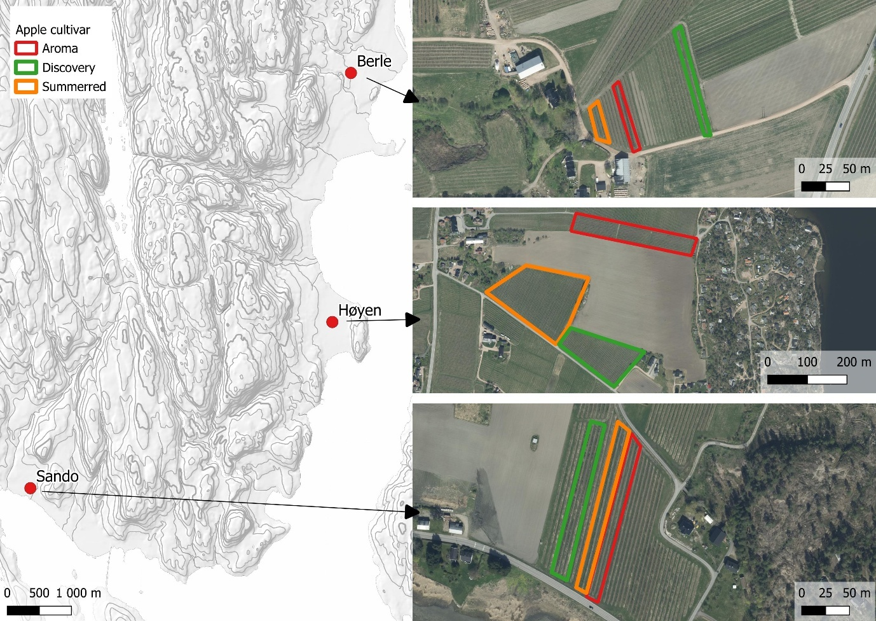
Map over Ullensvang in the west, with locations Djønno, Urheim, and Lofthus. All orchards outlined: Aroma (red), Discovery (green), and Summerred (orange)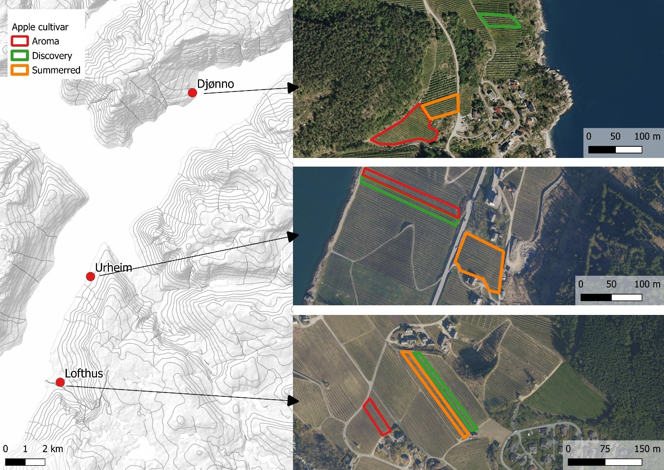

Appendix B – Statistical analysis and results from data collected from pan- and vane traps
Pan traps of three different colours: blue, white, and yellow, and vane trap with a blue top and yellow collector.
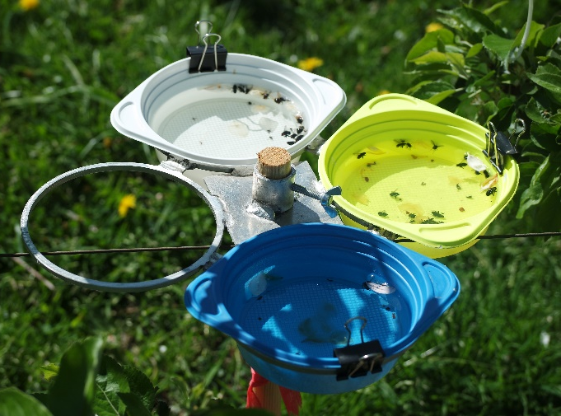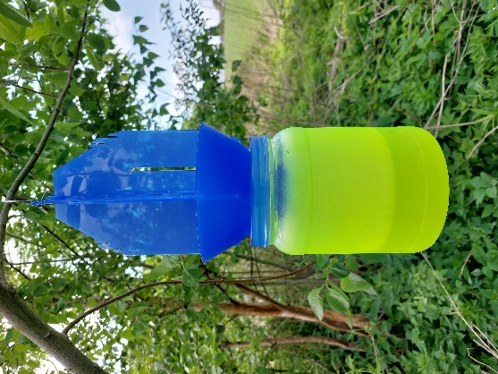
Statistical analysis:
We assessed if species richness and abundance varied depending on the trap type (blue-, white-, and yellow pan traps and vane trap) and placement of trap (centre of orchard or edge of orchard). Species richness and abundance are the total collection of species, pooled by orchard (location + apple cultivar), trap type, and collection date. These analyses were used to justify the use of different trap types and trap placement to be able to get a representable collection of pollinating bees. Location was added as random effect, the response variable is count data and Poisson error distribution was added. Model fit was assessed using the performance package in R and ANOVA.
Response variable | Fixed effect | Random effect | Error distribution
Species richness | Trap type + trap placement | Location | Poisson
Abundance | Trap type + trap placement | Location | Poisson

Species accumulation curve was calculated by plotting the cumulative number of species across the flowering season per trap, pan traps of three different colours (blue, yellow, and white) and vane traps.
Results on effect of trap type and trap placement on bee species richness and abundance
Species richness and abundance varied among traps (P-value < 0.001 for both). Vane traps caught a higher species richness and abundance compared to all pan traps. Blue and yellow pan traps also caught a higher abundance than white pan traps (Fig. a) No difference was found for species richness between the two different placements of the traps, inside and outside the orchard (P-value = 0.787), but traps outside the orchard caught a higher abundance compared to the traps inside the orchard (P-value < 0.001).
Species accumulation curves show that there was a difference in species richness caught in the different traps across the growing season (Fig. b). The curve did not reach an asymptote before end of flowering for any of the apple cultivars because the species richness was still increasing.
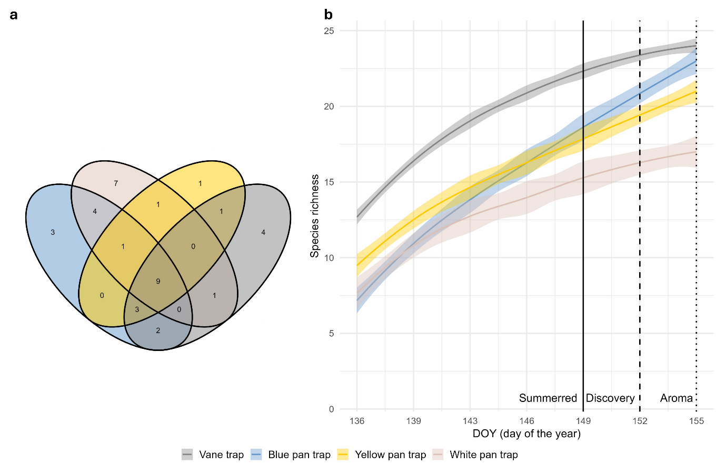
Figure (a) Venn diagram showing unique species of bees caught in the different traps: vane trap (grey), blue pan trap (blue), yellow pan trap (yellow), and white pan trap (beige), and (b) Species accumulation curve for the different traps, with species richness on the y-axis and day of the year (DOY), during apple flowering, on the x-axis. DOY corresponds to samples. Day when the different apple cultivars had senesced are marked with vertical lines: Summerred (solid), Discovery (dashed), and Aroma (dotted).
Difference in species richness and abundance caught in different traps and trap location
Analysis on difference in (a) species richness and (b) abundance among the different traps: vane trap, blue pan trap, white pan trap, and yellow pan trap, and between the trap placement: inside the orchard and the edge of the orchard, using mixed effect models. Significant values (P-value < 0.05) are indicated in bold.
- Species richness
 | Estimate ± SE | df | Z-value | P-value
Intercept (Trap centre/Blue pan trap) | 0.22 ± 0.15 | Inf | 1.52 | 0.130
Trap edge | -0.02 ± 0.08 | Inf | -0.27 | 0.787
Vane trap | 0.59 ± 0.12 | Inf | 5.05 | < 0.001
White pan trap | 0.11 ± 0.14 | Inf | 0.79 | 0.432
Yellow pan trap | 0.21 ± 0.13 | Inf | 1.64 | 0.101
- Abundance
 | Estimate ± SE | df | Z-value | P-value
Intercept (Trap centre/Blue pan trap) | 0.72 ± 0.30 | Inf | 2.40 | 0.017
Trap edge | 0.55 ± 0.04 | Inf | 12.42 | < 0.001
Vane trap | 0.48 ± 0.06 | Inf | 8.23 | < 0.001
White pan trap | -0.23 ± 0.07 | Inf | -3.11 | 0.002
Yellow pan trap | 0.02 ± 0.07 | Inf | -0.32 | 0.753

Results from post-hoc comparison among trap types and placement for (a) species richness and (b) species abundance. Significant values (P-value < 0.05) are indicated in bold.
- Species richness
 | Estimate ± SE | df | Z-ratio | P-value
Inside – Outside | 0.02 ± 0.08 | Inf | 0.27 | 0.787
Blue pan trap – Vane trap | -0.59 ± 0.12 | Inf | -5.05 | < 0.001
Blue pan trap – White pan trap | -0.11 ± 0.14 | Inf | -0.79 | 0.861
Blue pan trap – Yellow pan trap | -0.21 ± 0.13 | Inf | -1.64 | 0.357
Vane trap – White pan trap | 0.48 ± 0.11 | Inf | 4.58 | < 0.001
Vane trap – Yellow pan trap | 0.38 ± 0.10 | Inf | 3.88 | < 0.001
White pan trap – Yellow pan trap | -0.11 ± 0.12 | Inf | -0.88 | 0.813
- Abundance
 | Estimate ± SE | df | Z-ratio | P-value
Inside – Outside | -0.55 ± 0.04 | Inf | -12.42 | < 0.001
Blue pan trap – Vane trap | -0.48 ± 0.06 | Inf | -8.23 | < 0.001
Blue pan trap – White pan trap | 0.23 ± 0.07 | Inf | 3.11 | 0.010
Blue pan trap – Yellow pan trap | 0.02 ± 0.07 | Inf | 0.32 | 0.989
Vane trap – White pan trap | 0.71 ± 0.06 | Inf | 11.42 | < 0.001
Vane trap – Yellow pan trap | 0.50 ± 0.06 | Inf | 9.12 | < 0.001
White pan trap – Yellow pan trap | -0.21 ± 0.07 | Inf | -2.93 | 0.018

Appendix C – Bee species richness, abundance and diversity indices
Bee species and number of individuals (log transformed) caught in pan- and vane traps in six different locations: Berle, Høyen, Sando, Lofthus, Urheim, and Djønno. Locations in Svelvik (east) on the left, and Ullensvang (west) on the right. Each bar is colour coded by genus.
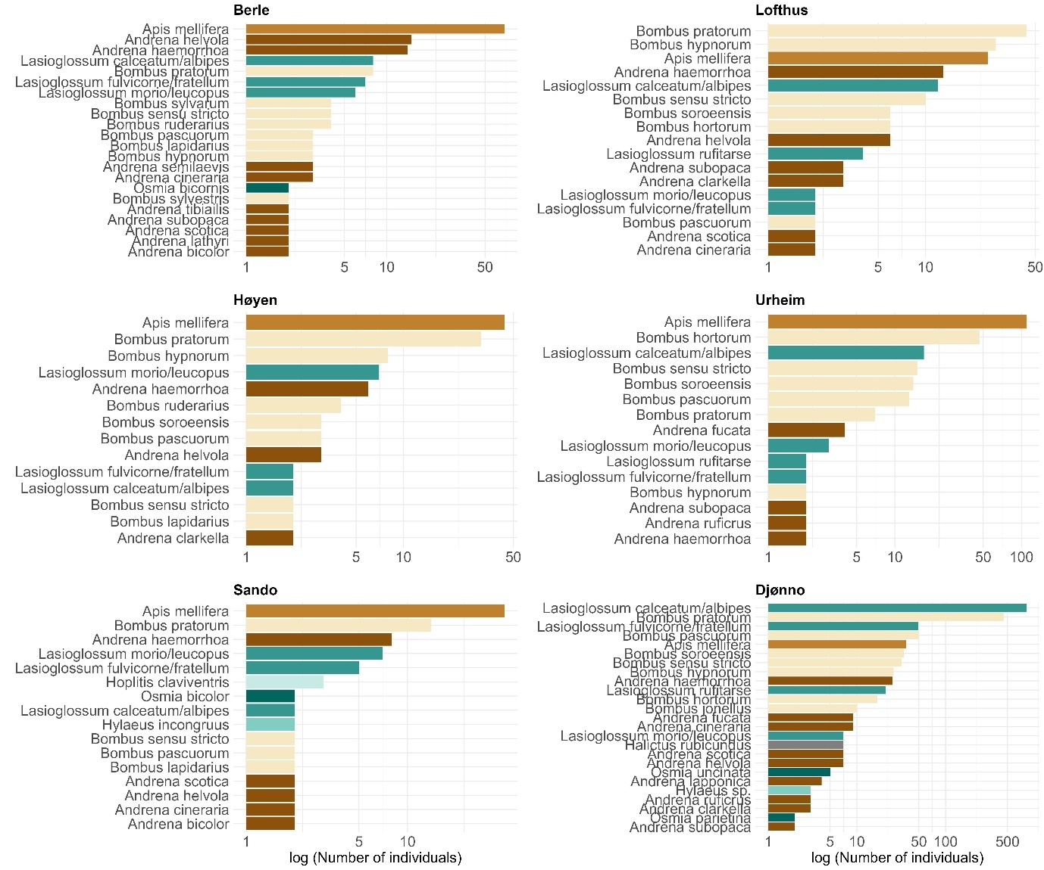

Appendix D – Model output and post-hoc Tukey tests
Variation in species richness and abundance among locations
Analysis on difference in (a) species richness and (b) abundance among the six locations: Berle, Djønno, Høyen, Lofthus, Sando, and Urheim, using mixed effect models. Significant values (P-value < 0.05) are indicated in bold.
- Species richness
 | Estimate ± SE | df | Z-value | P-value
Intercept (Berle) | 0.41 ± 0.10 | Inf | 4.07 | < 0.001
Djønno | 0.58 ± 0.12 | Inf | 4.96 | < 0.001
Høyen | -0.11 ± 0.16 | Inf | -0.71 | 0.479
Lofthus | 0.11 ± 0.15 | Inf | 0.74 | 0.462
Sando | -0.08 ± 0.16 | Inf | -0.47 | 0.637
Urheim | 0.16 ± 0.13 | Inf | 1.17 | 0.243
- Abundance
 | Estimate ± SE | df | Z-value | P-value
Intercept (Berle) | 0.81 ± 0.08 | Inf | 9.78 | < 0.001
Djønno | 1.97 ± 0.09 | Inf | 22.74 | < 0.001
Høyen | -0.05 ± 0.13 | Inf | -0.37 | 0.713
Lofthus | 0.25 ± 0.12 | Inf | 2.17 | 0.030
Sando | -0.18 ± 0.14 | Inf | -1.27 | 0.204
Urheim | 0.34 ± 0.11 | Inf | 3.20 | 0.001

Results from post-hoc comparison among locations for (a) species richness and (b) abundance. Significant values (P-value < 0.05) are indicated in bold.
- Species richness
 | Estimate ± SE | df | Z-ratio | P-value
Berle - Djønno | -0.58 ± 0.118 | Inf | -4.96 | < 0.001
Berle - Høyen | 0.11 ± 0.16 | Inf | 0.71 | 0.981
Berle - Lofthus | -0.11 ± 0.15 | Inf | -0.74 | 0.978
Berle - Sando | 0.08 ± 0.16 | Inf | 0.47 | 0.997
Berle - Urheim | -0.16 ± 0.13 | Inf | -1.17 | 0.853
Djønno - Høyen | 0.70 ± 0.14 | Inf | 5.08 | < 0.001
Djønno - Lofthus | 0.48 ± 0.12 | Inf | 3.90 | 0.001
Djønno - Sando | 0.66 ± 0.14 | Inf | 4.64 | < 0.001
Djønno - Urheim | 0.43 ± 0.11 | Inf | 3.97 | 0.001
Høyen - Lofthus | -0.22 ± 0.16 | Inf | -1.36 | 0.753
Høyen - Sando | -0.04 ± 0.18 | Inf | -0.20 | 1.000
Høyen - Urheim | -0.27 ± 0.15 | Inf | -1.78 | 0.481
Lofthus - Sando | 0.19 ± 0.17 | Inf | 1.11 | 0.878
Lofthus - Urheim | -0.05 ± 0.14 | Inf | -0.36 | 0.999
Sando - Urheim | -0.23 ± 0.16 | Inf | -1.50 | 0.667
- Abundance
 | Estimate ± SE | df | Z-ratio | P-value
Berle - Djønno | -1.97 ± 0.085 | Inf | -22.74 | < 0.001
Berle - Høyen | 0.047 ± 0.13 | Inf | 0.37 | 1.000
Berle - Lofthus | -0.25 ± 0.12 | Inf | -2.17 | 0.252
Berle - Sando | 0.18 ± 0.14 | Inf | 1.27 | 0.801
Berle - Urheim | -0.34 ± 0.11 | Inf | -3.20 | 0.018
Djønno - Høyen | 2.01 ± 0.10 | Inf | 19.98 | < 0.001
Djønno - Lofthus | 1.71 ± 0.08 | Inf | 20.30 | < 0.001
Djønno - Sando | 2.14 ± 0.11 | Inf | 18.81 | < 0.001
Djønno - Urheim | 1.63 ± 0.07 | Inf | 22.95 | < 0.001
Høyen - Lofthus | -0.30 ± 0.13 | Inf | -2.35 | 0.174
Høyen - Sando | 0.13 ± 0.15 | Inf | 0.87 | 0.953
Høyen - Urheim | -0.39 ± 0.12 | Inf | -3.27 | 0.014
Lofthus - Sando | 0.43 ± 0.14 | Inf | 3.12 | 0.023
Lofthus - Urheim | -0.09 ± 0.11 | Inf | -0.84 | 1.000
Sando - Urheim | -0.52 ± 0.13 | Inf | -4.00 | 0.001

Difference in behaviour among bumblebees, honeybees and solitary bees
Analysis on difference in (a) flower handling time (s) per visit, (b) number of visits, and (c) probability of visits with stigma contact per observed bee throughout the apple flowering season (day of the year; DOY), among three groups of bees: honeybees, bumblebees, and solitary bees, using linear mixed effect models. Significant values (P-value < 0.05) are indicated in bold.
- Flower handling time
 | Estimate ± SE | Z-value | P-value
Intercept (Bumblebee) | 0.81 ± 0.02 | 46.82 | < 0.001
Honeybee | 0.68 ± 0.03 | 25.89 | < 0.001
Solitary bee | 0.93 ± 0.06 | 14.69 | < 0.001
- Visitation
 | Estimate ± SE | Z-value | P-value
Intercept (Bumblebee) | 2.70 ± 0.06 | 42.52 | < 0.001
Honeybee | -0.63 ± 0.08 | -7.47 | < 0.001
Solitary bee | -1.12 ± 0.15 | -7.34 | < 0.001
- Stigma contact through DOY
 | Estimate ± SE | Z-value | P-value
Intercept (Bumblebee) | 17.91 ± 3.44 | 5.20 | < 0.001
Honeybee | -1.08 ± 0.20 | -5.41 | < 0.001
Solitary bee | -0.20 ± 0.42 | -0.48 | 0.629
DOY | -0.10 ± 0.02 | -4.36 | < 0.001

Analysis on difference in bee movement among each foraging event split into three categories: New flower on the same tree, new tree, or new row/further, among three groups of bees: honeybees, bumblebees, and solitary bees, using multinomial model. Significant values (P-value < 0.05) are indicated in bold.
Bee movement:
 | Intercept (Bumblebee and new flower) | Honeybee | Solitary bee
New row | -3.56 ± 0.13 | 0.37 ± 0.18 | 0.43 ± -0.41
New tree | -2.38 ± 0.07 | 0.21 ± 0.11 | -0.39 ± 0.33

Results from post-hoc comparison on differences in (a) flower handling time, (b) number of visits, and (c) stigma contact among bumblebees, honeybees and solitary bees. Significant values (P-value < 0.05) are indicated in bold.

- Flower handling time
 | Estimate ± SE | df | Z-ratio | P-value
Bumblebee - Honeybee | -0.68 ± 0.03 | 4968 | -25.89 | < 0.001
Bumblebee – Solitary bee | -0.93 ± 0.06 | 4968 | -14.69 | < 0.001
Honeybee – Solitary bee | -0.25 ± 0.06 | 4968 | -3.86 | < 0.001
- Visitation
 | Estimate ± SE | df | Z-ratio | P-value
Bumblebee – Honeybee | 0.63 ± 0.06 | Inf | 7.47 | < 0.001
Bumblebee – Solitary bee | 1.11 ± 0.15 | Inf | 7.34 | < 0.001
Honeybee – Solitary bee | 0.48 ± 0.15 | Inf | 3.27 | 0.001
- Stigma contact
 | Estimate ± SE | df | Z-ratio | P-value
Honeybee - Bumblebee | 1.08 ± 0.20 | Inf | 5.41 | < 0.001
Honeybee – Solitary bee | 0.20 ± 0.42 | Inf | 0.48 | 0.879
Bumblebee – Solitary bee | -0.87 ± 0.41 | Inf | -2.14 | 0.083

Difference in seed set among locations
Analysis on difference of how seed set (ratio) varies among the six locations: Berle, Djønno, Høyen, Lofthus, Sando, and Urheim, using linear mixed effect models. Significant values (P-value < 0.05) are indicated in bold.
Seed set among locations
 | Estimate ± SE | Z-value |  | P-value
Intercept (Berle) | 0.59 ± 0.12 | 4.99 |  | < 0.001
Djønno | -1.51 ± 0.17 | -6.68 |  | < 0.001
Høyen | -0.55 ± 0.17 | -3.21 |  | 0.001
Lofthus | -0.28 ± 0.17 | -1.67 |  | 0.095
Sando | 0.09 ± 0.17 | 0.56 |  | 0.574
Urheim | -0.33 ± 0.17 | -1.95 |  | 0.052

Results from post-hoc comparison on variations in seed set among locations. Significant values (P-value < 0.05) are indicated in bold.
Seed set among locations
 | Estimate ± SE | df | Z-ratio | P-value
Berle - Djønno | 1.15 ± 0.17 | Inf | 6.68 | < 0.001
Berle - Høyen | 0.55 ± 0.17 | Inf | 3.21 | 0.017
Berle - Lofthus | 0.28 ± 0.17 | Inf | 1.67 | 0.552
Berle - Sando | -0.09 ± 0.17 | Inf | -0.56 | 0.993
Berle - Urheim | 0.33 ± 0.17 | Inf | 1.95 | 0.373
Djønno - Høyen | -0.60 ± 0.18 | Inf | -3.41 | 0.009
Djønno - Lofthus | -0.86 ± 0.17 | Inf | -4.99 | < 0.001
Djønno - Sando | -1.24 ± 0.17 | Inf | -7.24 | < 0.001
Djønno - Urheim | -0.81 ± 0.18 | Inf | -4.60 | < 0.001
Høyen - Lofthus | -0.27 ± 0.17 | Inf | -1.55 | 0.632
Høyen - Sando | -0.64 ± 0.17 | Inf | -3.77 | 0.002
Høyen - Urheim | -0.22 ± 0.18 | Inf | -1.23 | 0.824
Lofthus - Sando | -0.37 ± 0.17 | Inf | -2.232 | 0.223
Lofthus - Urheim | 0.05 ± 0.17 | Inf | 0.298 | 1.000
Sando - Urheim | 0.42 ±0.17 | Inf | 2.504 | 0.123

Analysis of how pollination success (seed set rate) is affected by species richness of wild bees, abundance of wild bees, abundance from honeybees, orchard design (block or integrated), and tree placement (edge or centre) using generalised linear mixed effect models. Significant values (P-value < 0.05) are indicated in bold.
 | Estimate ± SE | Z-value | P-value
Intercept | -1.23 ± 0.43 | -2.87 | 0.004
Integrated design | 0.92 ± 0.23 | 3.95 | < 0.001
Tree edge | 0.26 ± 0.13 | 2.03 | 0.016
Species richness wild bees | 0.01 ± 0.02 | 0.59 | 0.554
Abundance wild bees | 0.01 ± 0.01 | 3.847 | < 0.001
Abundance honeybees | 0.01 ± 0.01 | 0.63 | 0.528
Discovery | 1.08 ± 0.10 | 10.78 | < 0.001
Summerred | 0.25 ± 0.10 | 2.07 | 0.038
Integrated design * tree edge | -0.22 ± 0.17 | -1.34 | 0.179

Appendix E – Multicollinearity analysis:
Model 5:
We initially fitted a model including an interaction between bee group and day of the year (DOY). Collinearity diagnostics indicated high multicollinearity when interaction term was included, with high variance inflation factors (VIF: Bee group = 2.20 x 10^6; Bee group * DOY = 2.16 x 10^6; DOY = 5.10). When interaction was removed (bee group + DOY), multicollinearity was not detected (VIF: Bee group = 1.02; DOY = 1.02). Interaction term was therefore excluded from the final model.
Model 8:
We initially fitted a model including an interaction between species richness of wild bees and wild bee abundance. Collinearity diagnostics indicated high multicollinearity when interaction term was included, with high variance inflation factors (VIF: Wild bee abundance = 22.72; Species richness * Wild bee abundance = 23.74; Species richness = 1.99). When interaction was removed (Species richness + Wild bee abundance), multicollinearity was not detected (VIF: Wild bee abundance = 2.73; Species richness = 2.29). Interaction term was therefore excluded from the final model. VIF for honeybee abundance in final model was 1.12, Orchard structure was 1.55, Tree placement was 2.83 and Orchard structure and its interaction with Tree placement was 2.93.

