
Appendices to J Poll Ecol 41(3), Scally et al.
DOI: 10.26786/1920-7603(2026)856

Supplementary Fig. 1. Satellite photos of the fields where the caging experiments were performed. The upper panel shows the “agricultural” field with a predominance of cultivated areas (34°12'13" S 59°33'39" W) and the lower panel shows the “semi-natural” field, with a predominance of natural and semi-natural areas (34°14'20" S; 59°28'46" W). Updated Google satellite imagery (Map Data: ©2023 Google, Airbus, CNES). Trial sites are indicated in each panel. Details in Scally et al. (2025).
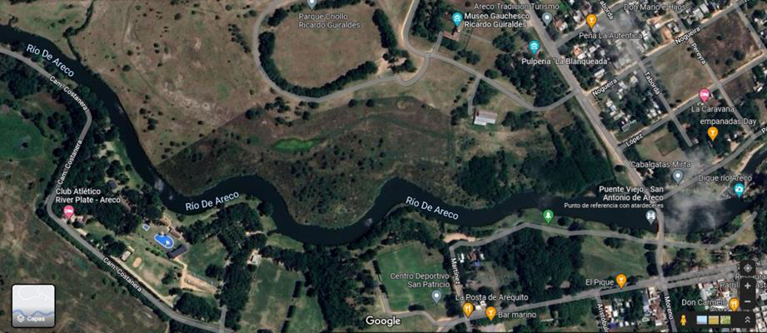
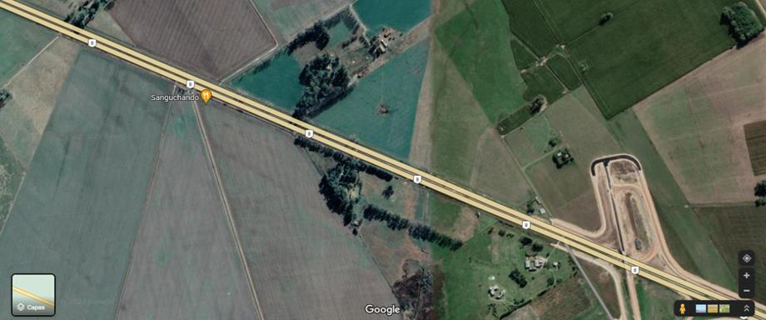

Test plots

Test plots

Supplementary Fig. 2. Pollination treatments (A. mellifera only: +A, Open: OP, Exclusion: EX) in the field located at a semi-natural habitat.
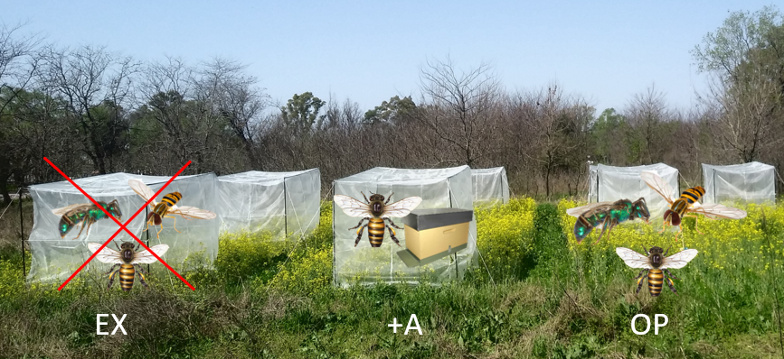
Supplementary Table 1. Results of the statistical analysis comparing pollination treatments (A. mellifera only, Open, Exclusion) and years (2021, 2022) for rapeseed yield components. Bold letters indicate significant differences between pollination treatments or years. ANOVA results (Wald F-tests). Df: degrees of freedom
A | Yield component |  |  | Effect | df | F | p
 | Seed yield |  |  | Pollination | 2, 473 | 11.142 | <0.001
 |  |  |  | Year | 1, 473 | 48.511 | <0.001
 |  |  |  | Pollination x Year | 2, 473 | 3.192 | 0.203
 | Seeds per fruit |  |  | Pollination | 2, 473 | 79.294 | <0.001
 |  |  |  | Year | 1, 473 | 88.282 | <0.001
 |  |  |  | Pollination x Year | 2, 473 | 3.052 | 0.058
 | Fruits per plant |  |  | Pollination | 2, 473 | 16.427 | <0.001
 |  |  |  | Year | 1, 473 | 333.277 | <0.001
 |  |  |  | Pollination x Year | 2, 473 | 0.439 | 0.645
 | Seed weight |  |  | Pollination | 2, 89 | 2.290 | 0.102
 |  |  |  | Year | 1, 89 | 8.328 | 0.004
 |  |  |  | Pollination x Year | 2, 89 | 1.565 | 0.210
 | Seed yield |  |  | Pollination | 2, 473 | 11.142 | <0.001
 |  |  |  | Year | 1, 473 | 48.511 | <0.001
 |  |  |  | Pollination x Year | 2, 473 | 3.192 | 0.203

B | Yield component |  |  | Effect | df | F | P
 | Fruit set |  |  | Pollination | 2, 137 | 90.226 | < 0.001
 |  |  |  | Year | 1, 137 | 5.868 | 0.016
 |  |  |  | Pollination x Year | 2, 137 | 0.484 | 0.617
 | Flower longevity |  |  | Pollination | 2, 137 | 3.301. | < 0.001
 |  |  |  | Year | 1, 137 | 68.711 | 0.010
 |  |  |  | Pollination x Year | 2, 137 | 0.4579 | 0.633
 | Ripe seeds |  |  | Pollination | 2, 137 | 586.643 | < 0.001
 |  |  |  | Year | 1, 137 | 518.146 | < 0.001
 |  |  |  | Pollination x Year | 2, 137 | 137 | 0.518
 | Germination power |  |  | Pollination | 2, 137 | 16.427 | <0.001
 |  |  |  | Year | 1, 137 | 333.277 | <0.001
 |  |  |  | Pollination x Year | 2, 137 | 4.515 | 0.063
 | Vigor |  |  | Pollination | 2, 137 | 2.290 | 0.012
 |  |  |  | Year | 1, 137 | 8.328 | 0.004
 |  |  |  | Pollination x Year | 2, 137 | 1.565 | 0.210

Yield component | Comparison | Df | t-ratio | P
Fruit set | Am - Open | 138 | 5.364 |  | <0.001
Fruit set | Am - Exc | 138 | 12.328 |  | <0.001
Fruit set | Open - Exc | 138 | 6.964 |  | <0.001
Seeds per fruit | Am - Open | 475 | 5.845 |  | <0.001
Seeds per fruit | Am - Exc | 475 | 12.134 |  | <0.001
Seeds per fruit | Open - Exc | 475 | 6.289 |  | <0.001
Fruits per plant | Am - Open | 475 | 1.481 |  | 0.301
Fruits per plant | Am - Exc | 475 | 5.413 |  | <0.001
Fruits per plant | Open - Exc | 475 | 3.932 |  | <0.001
Seed weight | Am - Open | 475 | -1.091 |  | 0.5202
Seed weight | Am - Exc | 475 | -0.825 |  | 0.6874
Seed weight | Open - Exc | 475 | -1.607 |  | 0.2437
Seed yield | Am - Open | 91 | 1.894 |  | 0.146
Seed yield | Am – Exc | 91 | 4.109 |  | <0.001
Seed yield | Open – Exc | 91 | 2.216 |  | 0.074
Flower longevity | Am – Open | 138 | -8.400 |  | <0.001
Flower longevity | Am – Exc | 138 | -25.677 |  | <0.001
Flower longevity | Open – Exc | 138 | -9.813 |  | <0.001
Ripe seeds | Am – Open | 138 | 4.414 |  | <0.001
Ripe seeds | Am – Exc | 138 | 10.991 |  | <0.001
Ripe seeds | Open – Exc | 138 | 6.274 |  | <0.001
Germination power | Am – Open | 138 | 7.350 |  | <0.001
Germination power | Am – Exc | 138 | 18.264 |  | <0.001
Germination power | Open – Exc | 138 | 11.284 |  | <0.001
Vigor | Am – Open | 138 | 8.817 |  | <0.001
Vigor | Am – Exc | 138 | 18.101 |  | <0.001
Vigor | Open – Exc | 138 | 11.697 |  | <0.001
Supplementary Table 2. Results of the Tukey post hoc comparisons among pollination treatments (A. mellifera only [Am], Open, Exclusion [Exc]) for quantitative (Fruit set, Seeds per fruit, Fruits per plant, Seed weight, Seed yield) and qualitative yield components (Flower longevity, Ripe seed, Germination Power and Vigor). T-ratios and corresponding P-values are reported. P-values were adjusted using the Bonferroni correction method. Bold letters indicate significant differences between treatments. Df: degrees of freedom.

Supplementary Table 3. Mean values of quantitative (Fruit set, Seeds per fruit, Fruits per plant, Seed weight, Seed yield) and qualitative yield components (Flower longevity, Ripe seed, Germination Power and Vigor) under different pollination treatments (A. mellifera only, Open, and Exclusion) for each study year (2021 and 2022).
 | Pollination treatment | Year
 | Pollination treatment | 2021 | 2022
Seeds per fruit | A. mellifera | 15.28 | 12.68
Seeds per fruit | Open | 13.91 | 11.18
Seeds per fruit | Exclusion | 11.68 | 10.31
Fruits per plant | A. mellifera | 88.88 | 52.63
Fruits per plant | Open | 87.16 | 49.11
Fruits per plant | Exclusion | 80.12 | 42.26
Seed weight | A. mellifera | 2.82 | 2.74
Seed weight | Open | 2.91 | 2.83
Seed weight | Exclusion | 2.95 | 2.88
Seed yield | A. mellifera | 2263.25 | 1030.34
Seed yield | Open | 1953.63 | 953.62
Seed yield | Exclusion | 1669.50 | 785.79
Flower longevity | A. mellifera | 3.19 | 3.37
Flower longevity | Open | 3.98 | 4.29
Flower longevity | Exclusion | 5.09 | 5.21
Fruit set | A. mellifera | 80.67 | 78.50
Fruit set | Open | 73.42 | 72.33
Fruit set | Exclusion | 66.00 | 62.33
Germination power | A. mellifera | 90.17 | 88.50
Germination power | Open | 85.86 | 82.33
Germination power | Exclusion | 71.50 | 67.50
Vigor | A. mellifera | 87.83 | 84.67
Vigor | Open | 78.17 | 76.66
Vigor | Exclusion | 63.00 | 61.33
Ripe seeds | A. mellifera | 92.66 | 84.67
Ripe seeds | Open | 86.33 | 76.66
Ripe seeds | Exclusion | 78.33 | 61.33

