# 

**Appendices to J Poll Ecol 38(2), Arnold et al.**

# [DOI: 10.26786/1920-7603(2025)797](https://doi.org/10.26786/1920-7603(2025)797)

Table S1: Mean number of available flowers (target/distractor) in acceptable condition available for each trial

|  |  |  |  |
| --- | --- | --- | --- |
| Trial | Distractor plant identity | Mean strawberry (target) flowers present | Mean distractor inflorescences present |
| 1a | Phacelia | 13.1 | 79.1 |
| 1b | Lavender | 60.4 | 25.7 |
| 2 | Lavender | 71.4 | 17.7 |
| 3 | Lavender | 56.9 | 91.1 |

Figure S1

Fig. S1 Aerial view of the experimental trial area, showing the twelve long, narrow experimental polytunnels arranged in three rows of four. Scale bar = 10m. Image source: Google Maps.

Figure S2

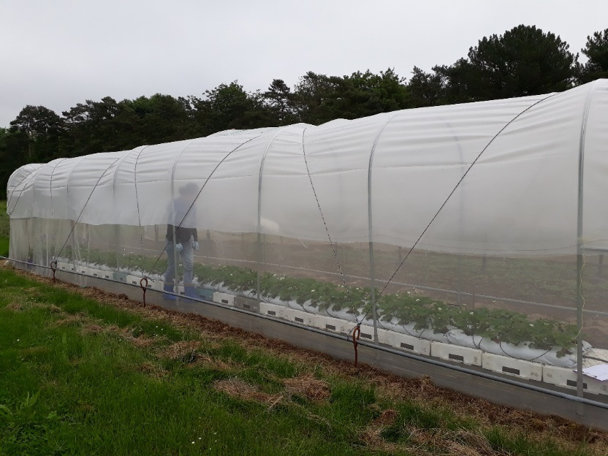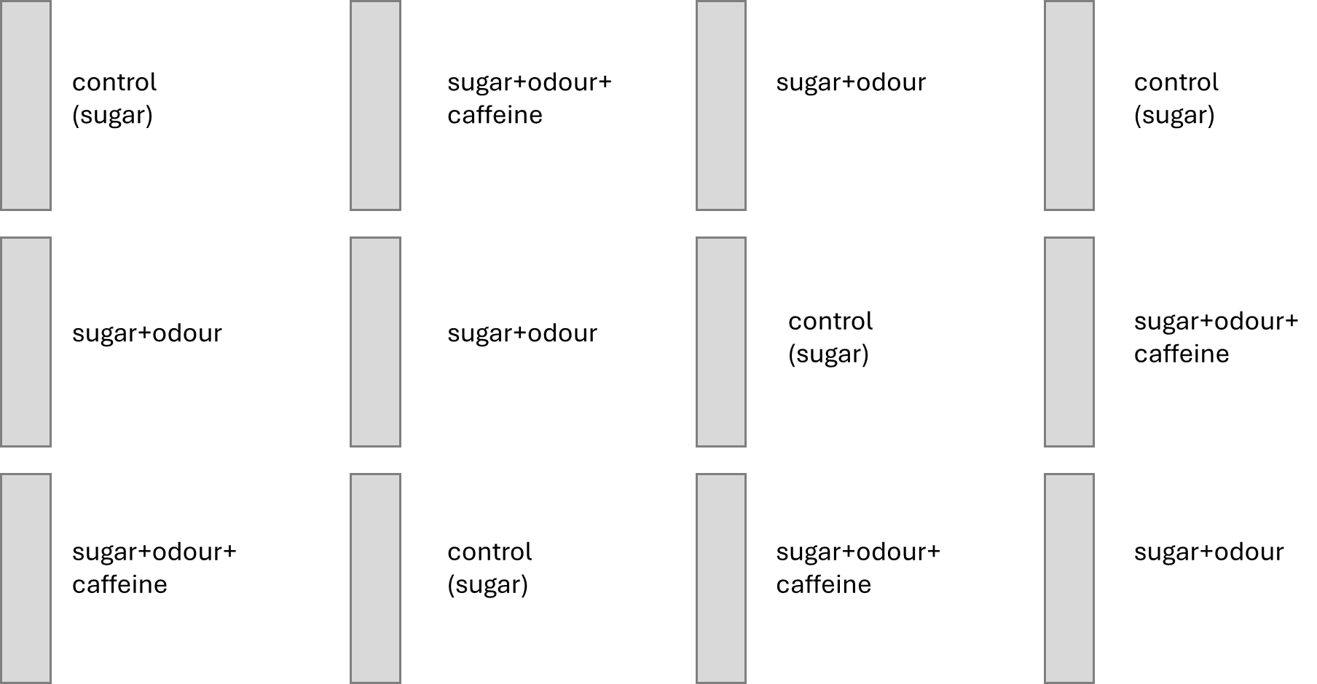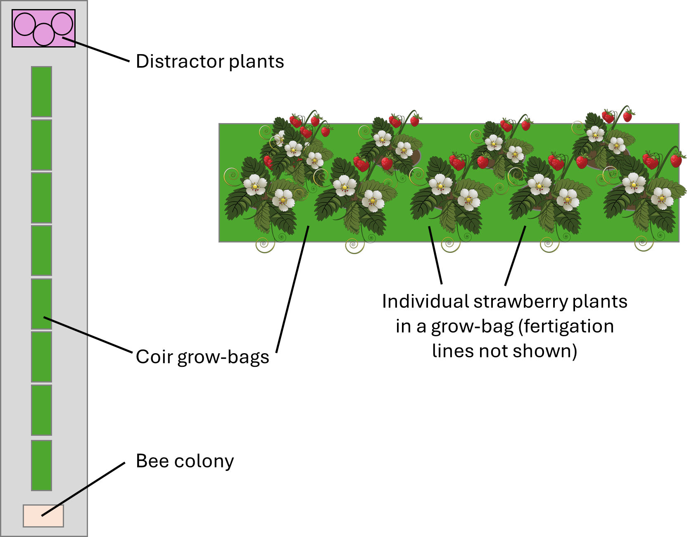

A

B

C

D

Figure S2 (A) A mini polytunnel showing the layout of plants in grow-bags. (B) Example layout of the mini polytunnels in the trial field. (C) Layout of plants within a single polytunnel as used in 2017. The bee colony was positioned at one end of the row of plants, and the distractor plants at the other. (D) Typical planting pattern of strawberry plants within a single coir bag.

Figure S3

(a)

(b)

Figure S3 Temperatures recorded in the polytunnels during trials in (a) 2017 (Trials 1 and 2) and (b) 2018 (Trial 3). Temperatures were comparable in polytunnels under all three treatments.

Supplementary information: Bumblebee hive health

Methodology: Hive health/growth assessments

We estimated the potential effects on colony growth of the priming treatments in all three trials. After the last assessment at the end of each trial, the hive exit door was closed and left overnight so the bumblebees in the tunnel could return to the hive but no longer exit. The next day all hives were frozen at -20°C for at least 72 hours. Hives were opened and assessed for numbers of females and males, differentiated by genitalia or the number of antennal segments (12 in females and 13 in males). Queens were identified by size.

Results: Hive health/growth

In the first two trials (Trial 1 and Trial 2), the initial colony size was standardised to 30 and a mean of 24.8 ± 0.27 (mean ± s.e.m.) bees respectively (Figure S4). In the third trial (Trial 3), the initial colony size was 64.6 ± 1.4 (mean ± s.e.m.) bees. Overall, treatment did not influence the final colony population when controlling for trial, at the end of the experiments (linear model, *F*6 = 0.7641, *p* = 0.604). Polytunnels assigned to the three treatments experienced the same temperatures throughout the trials (Fig. S3) so the colonies were not adversely influenced by environmental conditions that varied between treatments.

Figure S4

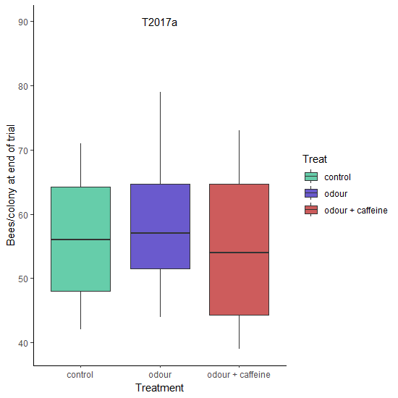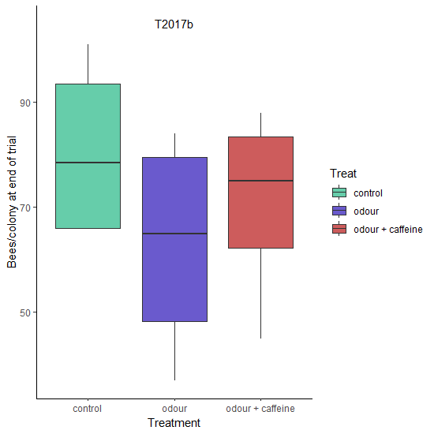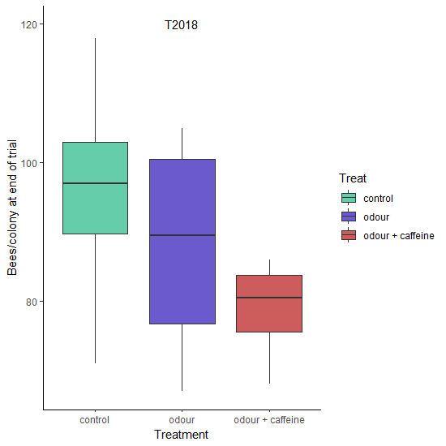

Trial 1

Trial 2

Trial 3

Figure S4. Mean number of bees per hive at the end of each trial. The initial number of bees were 30 in Trial 1, 25 in Trial 2 and 65 in Trial 3.