Appendices to J Poll Ecol 36(2), Lam et al.
DOI: 10.26786/1920-7603(2024)748

Contents:

Tables S1. Details of pollinator surveys.
Table S2. Categories and examples of pollinators.
Table S3. Details of ivy replicate locations.
Table S4. Results of Generalised Linear Models for number of pollinator visits.
Table S5. Results of Generalised Linear Model for fruit set.
Table S6. Results from Tukey’s HSD Tests for multiple comparisons of means for fruit set.
Table S7. Results of Generalised Linear Model for fruit size.
Table S8. Results from Tukey’s HSD Tests for multiple comparisons of means for fruit size.

Figure S1. Species accumulation curves and sample coverage curves from pollinator surveys.
Table S1. Details of pollinator surveys carried out, including date, temperature, and coordinates of the location.
Site | Date (d/m/y) | Temperature (°C) | Coordinates
Trumpington Meadows | 26/09/21 | 21.9 | 52.17118° N, 0.09959° E
(n = 12) |  | 21.0 | 52.17045° N, 0.09744° E
 |  | 21.4 | 52.17044° N, 0.09743° E
 | 27/09/21 | 18.7 | 52.17034° N, 0.09709° E
 |  | 15.8 | 52.17032° N, 0.09713° E
 |  | 18.8 | 52.17061° N, 0.09809° E
 | 29/09/21 | 18.3 | 52.17103° N, 0.09964° E
 | 03/10/21 | 18.2 | 52.17099° N, 0.09970° E
 | 10/10/21 | 18.2 | 52.17316° N, 0.10236° E
 |  | 16.2 | 52.17025° N, 0.09705° E
 | 12/10/21 | 18.2 | 52.17174° N, 0.10122° E
 |  | 18.3 | 52.17062° N, 0.09813° E
Botanic Garden | 26/09/21 | 23.7 | 52.19309° N, 0.12547° E
(n = 10) |  | 21.8 | 52.19318° N, 0.12574° E
 |  | 22.2 | 52.19249° N, 0.12763° E
 |  | 21.8 | 52.19250° N, 0.12761° E
 |  | 21.9 | 52.19269° N, 0.12887° E
 | 28/09/21 | 17.7 | 52.19254° N, 0.12762° E
 |  | 18.5 | 52.19257° N, 0.12897° E
 | 03/10/21 | 16.8 | 52.19326° N, 0.12573° E
 | 10/10/21 | 18.4 | 52.19285° N, 0.12606° E
 |  | 16.8 | 52.19258° N, 0.12887° E

Pollinator group | Example species, genera or families
Bumblebee | Bombus spp.
Honey bee | ﻿Apis mellifera
Solitary bee | Colletes hederae
Wasp | ﻿Vespula vulgaris
 | Vespula germanica
Hoverfly | ﻿Eristalis spp.
 | ﻿Helophilus spp.
Other flies | Calliphora spp.
 | Lucilia spp.
Butterfly | Vanessa atalanta
Small insects (<3mm) | Aphididae (aphids)
 | Small Diptera spp.
Table S2. Categories of pollinators and examples of ﻿species, genera or families observed to forage on ivy flowers.
Table S3. Coordinates of ivy plants involved in the pollination experiment at Trumpington Meadows and the Botanic Garden.
Site | Coordinates
Trumpington Meadows | 52.16994° N, 0.09598° E
(n = 12) | 52.17060° N, 0.09747° E
 | 52.17052° N, 0.09788° E
 | 52.16990° N, 0.09595° E
 | 52.16987° N, 0.09583° E
 | 52.16988° N, 0.09600° E
 | 52.17056° N, 0.09799° E
 | 52.17171° N, 0.10106° E
 | 52.17099° N, 0.09940° E
 | 52.17031° N, 0.09705° E
 | 52.17317° N, 0.10235° E
 | 52.17015° N, 0.09617° E
Botanic Garden | 52.19457° N, 0.12427° E
(n = 10) | 52.19328° N, 0.12587° E
 | 52.19277° N, 0.12603° E
 | 52.19252° N, 0.12757° E
 | 52.19253° N, 0.12760° E
 | 52.19256° N, 0.12890° E
 | 52.19260° N, 0.12918° E
 | 52.19378° N, 0.13083° E
 | 52.19282° N, 0.12617° E
 | 52.19290° N, 0.12620° E

Table S4a. Results of Generalised Linear Model for number of visits by all insects (with Poisson error structure and a log link). The number of umbels involved in each observation was included as an offset term. Effect estimates for all factors in the maximal model are presented.
Variable | Estimate | Std. Error | z value | P-value
(Intercept) | -0.784 | 0.071 | -11.06 | <0.001
Site:BG | -0.206 | 0.110 | -1.88 | 0.060
Table S4b. Results of Generalised Linear Model for number of visits by wasps only (with negative binomial error structure and a log link). The number of umbels involved in each observation was included as an offset term. Effect estimates for all factors in the maximal model are presented.
Variable | Estimate | Std. Error | z value | P-value
(Intercept) | -2.123 | 0.281 | -7.549 | <0.001
Site:BG | -0.273 | 0.424 | -0.643 | 0.520

Table S5a. Details of maximal Generalised Linear Model (with quasibinomial errors and logit link) for fruit set. Effect estimates for all factors in the maximal model are presented.
Variable | Estimate | Std. Error | t value | P-value
(Intercept) | -2.3640 | 0.3248 | -7.279 | <0.001
Site:BG | -0.4417 | 0.5843 | -0.756 | 0.453
Treatment:Open | 2.9554 | 0.3765 | 7.850 | <0.001
Treatment:Hand Pollinated | 4.2780 | 0.4318 | 9.908 | <0.001
Site:BG x Treatment:Open | 0.3515 | 0.6585 | 0.534 | 0.595
Site:BG x Treatment:Hand Pollinated | 0.8158 | 0.7577 | 1.077 | 0.286
Table S5b. Results of backwards stepwise elimination on Generalised Linear Model for fruit set. Changes in fit of the model after deletion of each term are presented, with the term(s) retained in the minimal model in bold.
Term deleted | d.f. | F value | P-value
Site x Treatment | 2 | 0.640 | 0.5309
Site | 1 | 0.0251 | 0.8747
Treatment | 2 | 160.07 | <0.001

Table S6. Results from Tukey’s HSD Tests for multiple comparisons of means for fruit set.
Treatments in comparison | Estimate | Std. Error | z value | d.f. | P-value
Open > Bagged | 3.0754 | 0.3039 | 10.119 | 42 | <0.001
Hand Pollinated > Bagged | 4.5762 | 0.3496 | 13.089 | 42 | <0.001
Hand Pollinated > Open | 1.5009 | 0.2698 | 5.563 | 42 | <0.001

Table S7a. Details of maximal Generalised Linear Model (with Gaussian errors) for fruit size. Effect estimates for all factors in the maximal model are presented.
Variable | Estimate | Std. Error | t value | P-value
(Intercept) | 5.25958 | 0.32249 | 16.309 | <0.001
Site:BG | -0.58208 | 0.55857 | -1.042 | 0.303
Treatment:Open | 2.07842 | 0.43267 | 4.804 | <0.001
Treatment:Hand Pollinated | 2.73842 | 0.43267 | 6.329 | <0.001
Site:BG x Treatment:Open | 0.05808 | 0.69167 | 0.084 | 0.933
Site:BG x Treatment:Hand Pollinated | 0.82008 | 0.69167 | 1.186 | 0.242

Table S7b. Results of backwards stepwise elimination on Generalised Linear Model for fruit size. Changes in fit of the model after each term deletion are presented, with the retained term(s) in bold.
Term deleted | d.f. | F value | P-value
Site x Treatment | 2 | 1.1163 | 0.3362
Site | 1 | 0.8398 | 0.364
Treatment | 2 | 41.981 | <0.001

Table S8. Results from Tukey’s HSD Tests for multiple comparisons of means for fruit size.
Treatments in comparison | Estimate | Std. Error | z value | d.f. | P-value
Open > Bagged | 2.0104 | 0.3333 | 6.031 | 30 | <0.001
Hand Pollinated > Bagged | 3.0514 | 0.3333 | 9.154 | 30 | <0.001
Hand Pollinated > Open | 1.0410 | 0.2858 | 3.606 | 38 | <0.001

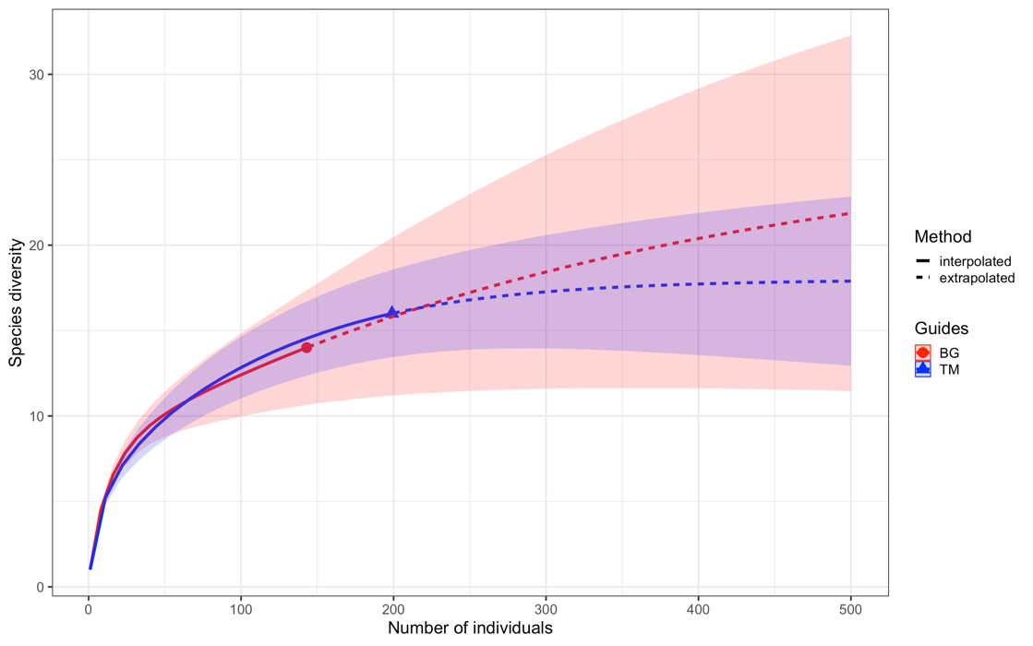
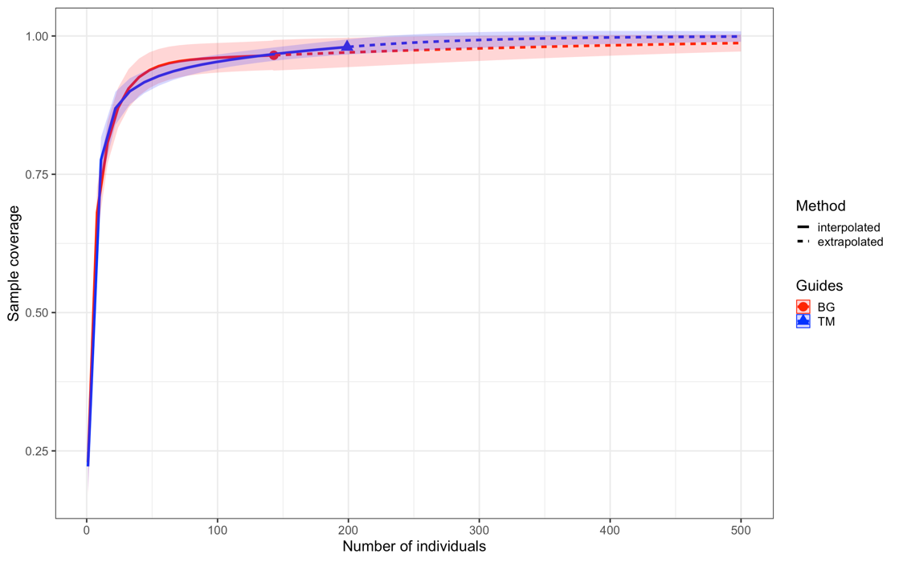
Figure S1. a) Sample-size-based species-accumulation curves with rarefaction (solid line) and extrapolation (dotted line) and 95% confidence intervals (shaded areas) based on pollinator surveys at Trumpington Meadows (blue) and the Botanic Garden (red). Number of morphospecies observed at Trumpington Meadows was 16 and that at the Botanic Garden was 14. The overall morphospecies richness was estimated to be higher at the Botanic Garden (26.413) than Trumpington Meadows (17.99). b) Sample completeness curves. Sample coverage estimate for Trumpington Meadows (98.01%) was higher than that for the Botanic Garden (96.51%).
a
b

