DOI: 10.26786/1920-7603(2022)701
Appendices to J Poll Ecol 32(18), Smith et al.
Appendix I: Floral morphology of the six plant species included in this study. All measurements were taken in mm. For visual descriptions of the dimensions measured for each species, see Figures S1_A-E; for the measurements themselves, see Tables S1_A-F.
Table S1_A: Floral dimensions for Datura wrightii. All measurements are in mm or g.
Plant | Flower Depth | Corolla D1 | Corolla D2 | Aperture | Depth to Aperture | Stamen Depth | Style Depth | Fresh Mass | Date
 | A | B | B | C | D | E | F
1 | 195 | 125 | 125 | 15 | 75 | 177 | 211 | 6.6603 | 28-Jun-21
2 | 181 | 122 | 124 | 17 | 65 | 150 | 177 | 6.5219 | 28-Jun-21
3 | 150 | 117 | 120 | 17 | 60 | 140 | 158 | 5.1522 | 28-Jun-21
4 | 180 | 121 | 123 | 12 | 70 | 150 | 175 | wilted | 28-Jun-21
5 | 170 | 120 | 122 | 15 | 70 | 150 | 167 | 5.6210 | 28-Jun-21
6 | 189 | 115 | 116 | 13 | 53 | 156 | 174 | 6.9096 | 29-Jun-21
7 | 190 | 113 | 116 | 14 | 74 | 171 | 189 | 6.4963 | 29-Jun-21
8 | 194 | 119 | 120 | 13 | 60 | 162 | 180 | 6.3249 | 29-Jun-21
9 | 191 | 127 | 130 | 16 | 81 | 170 | 204 | 7.7499 | 29-Jun-21
10 | 145 | 125 | 129 | 15 | 70 | 153 | 198 | 6.1059 | 2-Jul-21
11 | 198 | 126 | 130 | 13.5 | 80 | 175 | 212 | 7.3389 | 2-Jul-21
12 | 155 | 118 | 121 | 14 | 70 | 151 | 175 | 6.3145 | 2-Jul-21
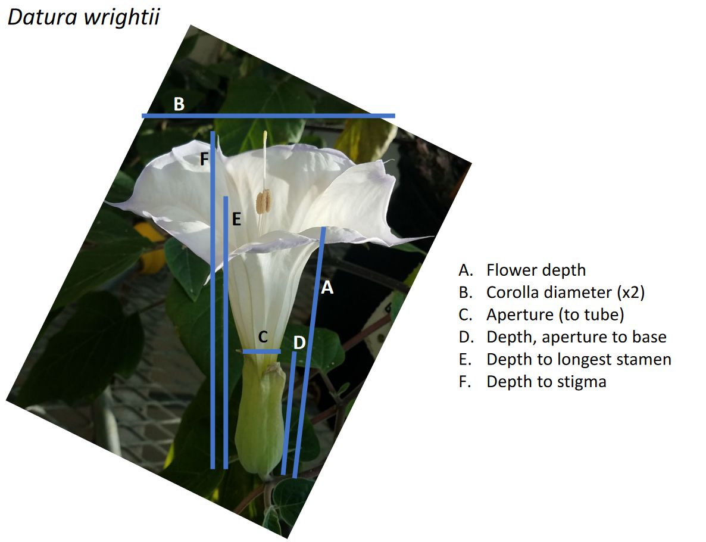
Figure S1_A: Floral measurements collected for Datura wrightii.
Table S1_B: Floral dimensions for Oenothera harringtonii. All measurements are in mm or g.
Plant | Flower Depth | Corolla D1 | Corolla D2 | Aperture | Depth to Aperture | Stamen Depth | Style Depth | Fresh Mass | Date
 | A | B | B | A | A | E | F
1 | 80 | 68 | 69 | 8 | 80 | 101 | 104 | 0.9077 | 20-Apr-21
2 | 65 | 59 | 59 | 7.5 | 65 | 80 | 89 | 0.8393 | 20-Apr-21
1 | 81 | 61 | 62 | 7.5 | 81 | 99 | 100 | 0.9125 | 21-Apr-21
1 | 85 | 68 | 69 | 8 | 85 | 101 | 105 | 0.9192 | 21-Apr-21
1 | 80 | 63 | 64 | 8 | 80 | 98 | 99 | 0.8054 | 21-Apr-21
2 | 62 | 60 | 60 | 8 | 62 | 78 | 88 | 0.8292 | 21-Apr-21
2 | 61 | 55 | 56 | 8 | 61 | 80 | 90 | 0.8399 | 21-Apr-21
3 | 64 | 55 | 54 | 7.5 | 64 | 82 | 84 | 0.6482 | 22-Apr-21
4 | 66 | 52 | 53 | 7 | 66 | 84 | 92 | 0.8078 | 22-Apr-21
3 | 80 | 60 | 58 | 7.5 | 80 | 94 | 97 | 0.5864 | 5-May-21
4 | 75 | 61 | 60 | 7.5 | 75 | 88 | 99 | 0.7592 | 5-May-21
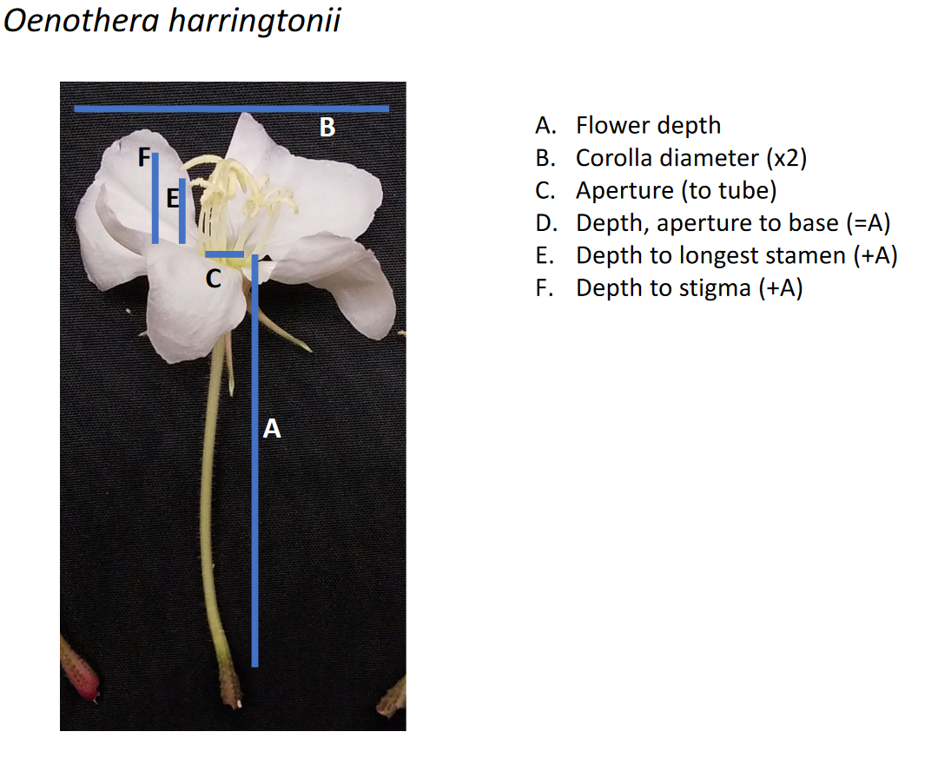
Figure S1_B: Floral measurements collected for Oenothera harringtonii.

Table S1_C: Floral dimensions for Mandevilla macrosiphon. All measurements are in mm or g.
Plant | Flower Depth | Corolla D1 | Corolla D2 | Aperture | Depth to Aperture | Stamen Depth | Style Depth | Fresh Mass | Date
 | A | B | B | C | D | D | D
1 | 95 | 48 | 47 | 35 | 70 | 70 | 70 | 0.7900 | 23-Apr-20
1 | 95 | 48 | 45 | 30 | 70 | 70 | 70 | 0.7433 | 23-Apr-20
1 | 98 | 42 | 44 | 30 | 75 | 75 | 75 | 0.7071 | 23-Apr-20
2 | 96 | 42 | 43 | 28 | 65 | 65 | 65 | 0.6052 | 23-Apr-20
2 | 80 | 42 | 41 | 28 | 50 | 50 | 50 | 0.5248 | 23-Apr-20
2 | 81 | 42 | 43 | 30 | 55 | 55 | 55 | 0.6143 | 23-Apr-20
4 | 87 | 41 | 41 | 30 | 68 | 68 | 68 | 0.6193 | 26-May-20
4 | 79 | 43 | 44 | 30 | 63 | 63 | 63 | 0.5511 | 27-May-20
4 | 91 | 56 | 60 | 30 | 73 | 73 | 73 | 0.6832 | 27-May-20
4 | 90 | 46 | 44 | 20 | 68 | 68 | 68 | 0.5269 | 29-May-20
4 | 86 | 49 | 51 | 25 | 67 | 67 | 67 | 0.5917 | 29-May-20
6 | 89 | 38 | 40 | 20 | 71 | 71 | 71 | 0.5650 | 2-Jun-20
6 | 70 | 29 | 31 | 20 | 53 | 53 | 53 | 0.5428 | 6-Jun-20
6 | 83 | 39 | 40 | 20 | 65 | 65 | 65 | 0.5251 | 6-Jun-20
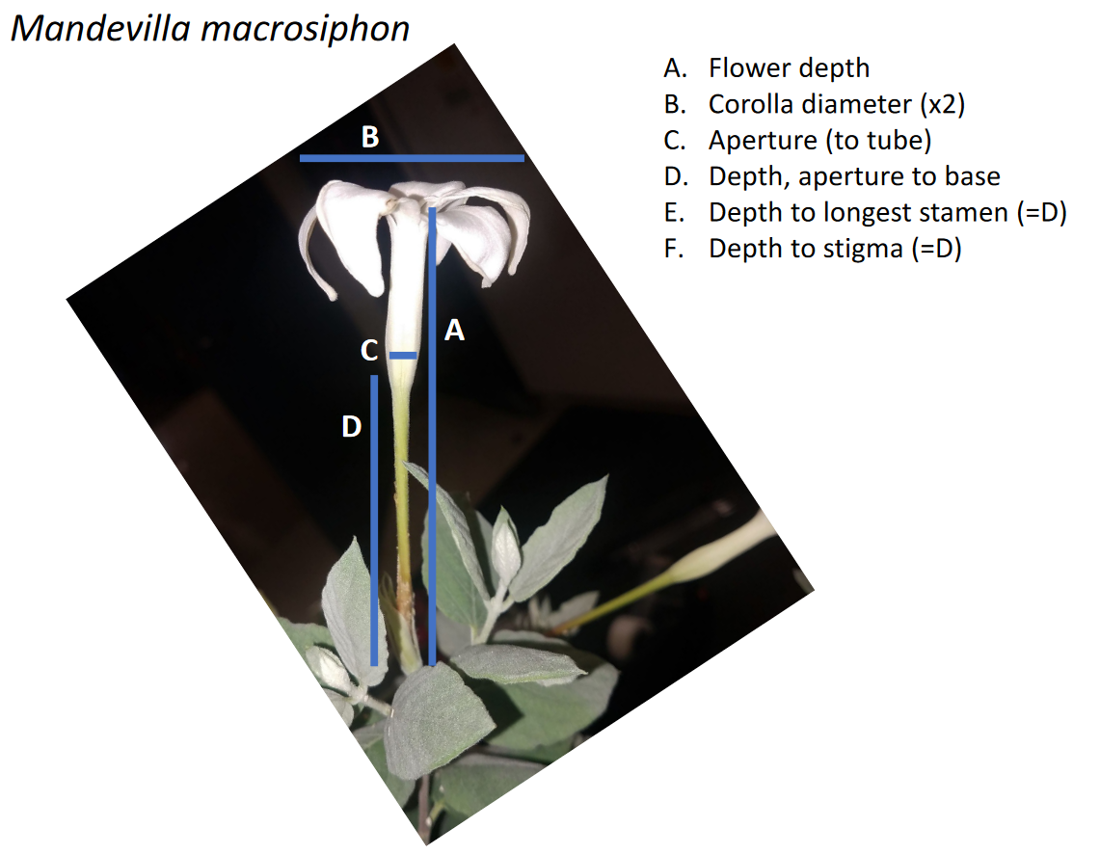
Figure S1_C: Floral measurements collected for Mandevilla macrosiphon.
Table S1_D: Floral dimensions for Ipomoea alba. All measurements are in mm or g.
Plant | Flower Depth | Corolla D1 | Corolla D2 | Aperture | Depth to Aperture | Stamen Depth | Style Depth | Fresh Mass | Date
 | A | B | B | C | A | E | F
1 | 102 | 150 | 146 | 7 | 102 | 123 | 127 | 2.8738 | 23-Jun-21
1 | 101 | 145 | 148 | 6.5 | 101 | 122 | 125 | 3.0458 | 23-Jun-21
2 | 108 | 135 | 132 | 7 | 108 | 128 | 132 | 2.4623 | 23-Jun-21
2 | 110 | 132 | 131 | 7.5 | 110 | 126 | 131 | 2.1913 | 23-Jun-21
2 | 105 | 138 | 139 | 7.5 | 105 | 129 | 133 | 2.3235 | 23-Jun-21
2 | 105 | 131 | 132 | 7 | 105 | 126 | 131 | 2.1235 | 23-Jun-21
3 | 103 | 131 | 134 | 7.5 | 103 | 126 | 136 | 2.0289 | 23-Jun-21
3 | 101 | 134 | 134 | 7 | 101 | 125 | 135 | 1.9727 | 23-Jun-21
4 | 105 | 128 | 126 | 7 | 105 | 123 | 130 | 2.4298 | 23-Jun-21
2 | 102 | 136 | 145 | 6 | 102 | 118 | 130 | 2.7434 | 27-Jun-21
2 | 106 | 141 | 142 | 6 | 106 | 121 | 127 | 3.1496 | 27-Jun-21
3 | 105 | 141 | 144 | 6.5 | 105 | 126 | 132 | 3.4632 | 27-Jun-21
3 | 106 | 141 | 142 | 6.5 | 106 | 123 | 131 | 3.1441 | 27-Jun-21
4 | 106 | 145 | 144 | 7 | 106 | 125 | 135 | 3.0715 | 27-Jun-21
4 | 103 | 139 | 140 | 6 | 103 | 115 | 129 | 3.0034 | 27-Jun-21

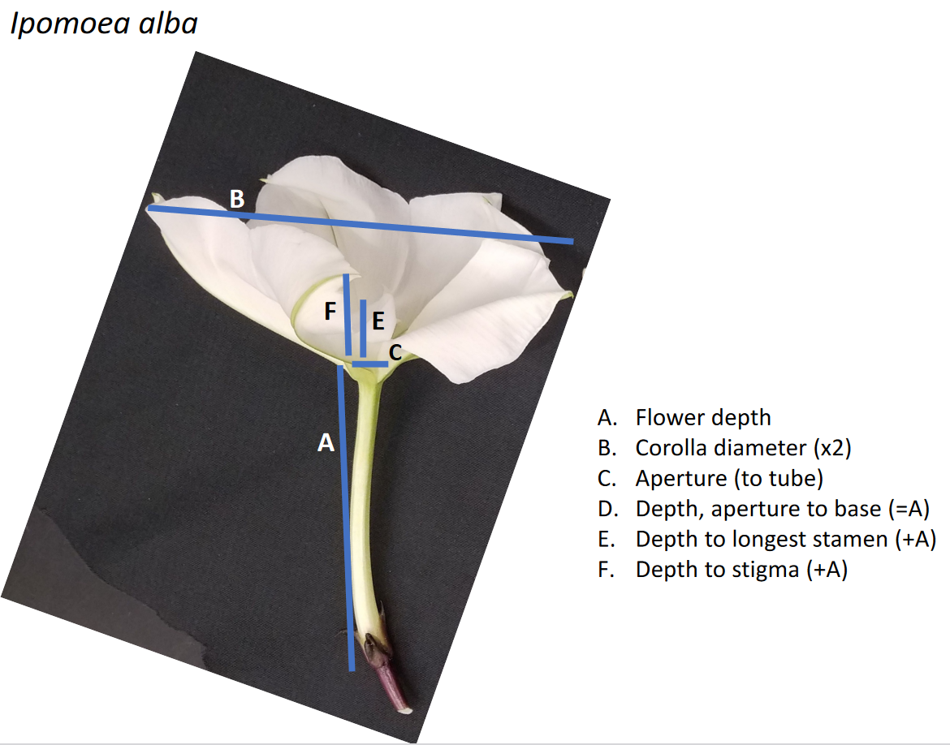
Figure S1_D: Floral measurements collected for Ipomoea alba.
Table S1_E: Floral dimensions for Mirabilis longiflora. All measurements are in mm or g.
Plant | Flower Depth | Corolla D1 | Corolla D2 | Aperture | Depth to Aperture | Stamen Depth | Style Depth | Fresh Mass | Date
 | A | B | B | C | A | E | F
1 | 100 | 24 | 21 | 5 | 100 | 134 | 138 | 0.2221 | 25-Jun-21
1 | 95 | 21 | 22 | 4.5 | 95 | 130 | 132 | 0.1872 | 25-Jun-21
1 | 100 | 25 | 25 | 5 | 100 | 133 | 134 | 0.2217 | 26-Jun-21
1 | 80 | 20 | 21 | 4 | 80 | 110 | 110 | 0.1661 | 26-Jun-21
1 | 95 | 23 | 25 | 5 | 95 | 127 | 129 | 0.2293 | 27-Jun-21
1 | 97 | 23 | 21 | 4.5 | 97 | 128 | 130 | 0.2209 | 27-Jun-21
1 | 97 | 24 | 23 | 4.5 | 97 | 132 | 127 | 0.2240 | 27-Jun-21
1 | 87 | 18 | 20 | 4 | 87 | 122 | 122 | 0.1733 | 27-Jun-21
1 | 105 | 28 | 28 | 4.5 | 105 | 133 | 133 | 0.2509 | 27-Jun-21
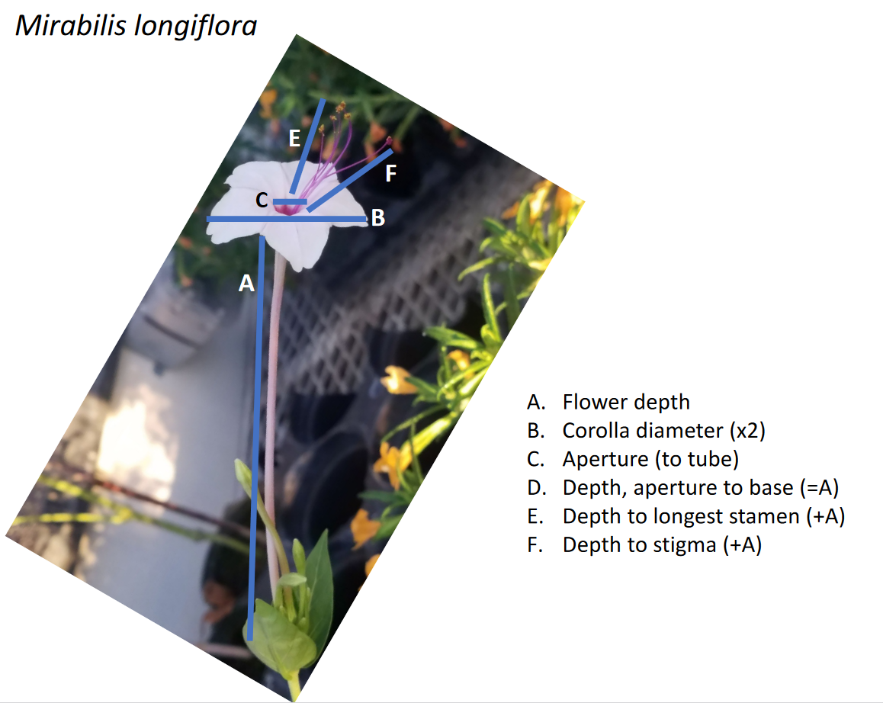
Figure S1_E: Floral measurements collected for Mirabilis longiflora.

Table S1_F: Floral dimensions for Mirabilis jalapa. All measurements are in mm or g. For a visual description of the dimensions measured, see Figure S1_E for Mirabilis longiflora, whose floral structure (though not size) is similar.
Plant | Flower Depth | Corolla D1 | Corolla D2 | Aperture | Depth to Aperture | Stamen Depth | Style Depth | Fresh Mass | Date
1 | 40 | 44 | 40 | 5 | 15 | 10 | 10 | 0.3465 | 8/23/21
1 | 33 | 45 | 38 | 4 | 14 | 10 | 12 | 0.3206 | 8/23/21
2 | 40 | 43 | 39 | 5 | 14 | 10 | 8 | 0.3107 | 8/23/21
3 | 37 | 43 | 34 | 4 | 16 | 10 | 11 | 0.2356 | 8/24/21
4 | 37 | 39 | 39 | 3 | 17 | 11 | 13 | 0.2669 | 8/30/21
5 | 33 | 30 | 27 | 3 | 20 | 14 | 14 | 0.1736 | 8/30/21
5 | 33 | 33 | 30 | 4 | 23 | 15 | 15 | 0.208 | 8/30/21
6 | 33 | 40 | 30 | 4 | 18 | 12 | 12 | 0.2963 | 8/30/21
3 | 34 | 34 | 33 | 3 | 17 | 14 | 14 | 0.2686 | 8/31/21
7 | 36 | 41 | 36 | 4 | 11 | 14 | 15 | 0.2944 | 9/6/21
8 | 38 | 45 | 38 | 4 | 12 | 8 | 10 | 0.283 | 9/6/21
9 | 35 | 40 | 30 | 3 | 20 | 9 | 10 | 0.2727 | 9/6/21
2 | 33 | 30 | 29 | 3 | 20 | 12 | 14 | 0.2438 | 9/6/21

Appendix II: Representative videos of hawkmoth visits to flowers of the study plants.
Video S2_A: Manduca sexta individual visiting the flowers of Ipmonea alba.
Video S2_B: Manduca sexta individual visiting the flowers of Mirabilis longiflora.
Video S2_C: Manduca sexta individual visiting the flowers of Oenothera harringtonii.
Video S2_D: Manduca sexta individual visiting the flowers of Mandevilla macrosiphon. As a note, the moths recorded here were not part of this study; all moths in the study were flown singly, rather than in groups.

