DOI: 10.26786/1920-7603(2022)697
Appendices to J Poll Ecol 32(11), Hodge et al.
Supplementary File S1. Photographs of trap nests used in this study. (A) attached to fence posts at three heights using single brackets with additional adhesive tape were required. (B) close up of tubes including some sealed with mud and leaves, and O. bicornis leaving a tube.
A.
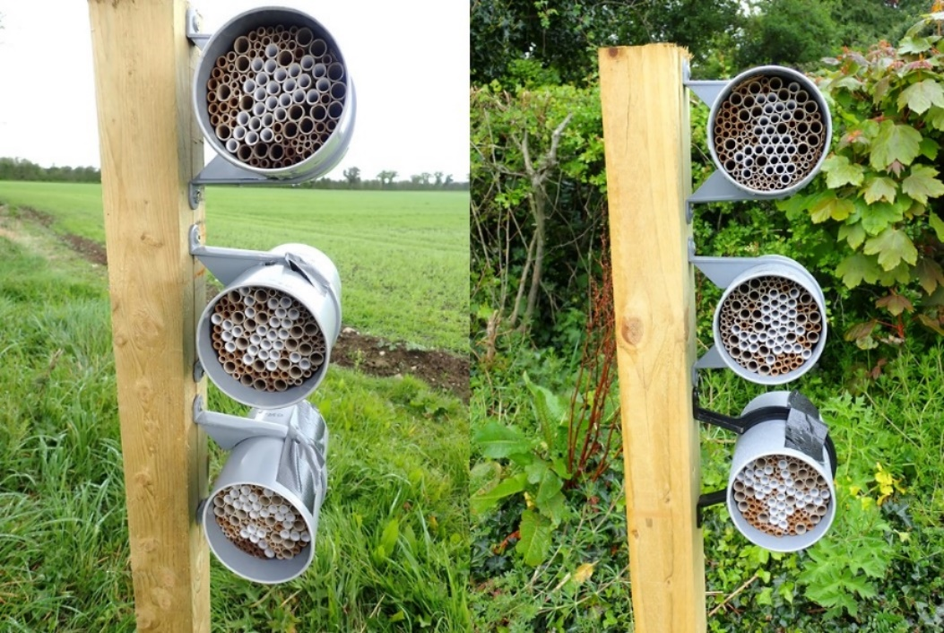
B.
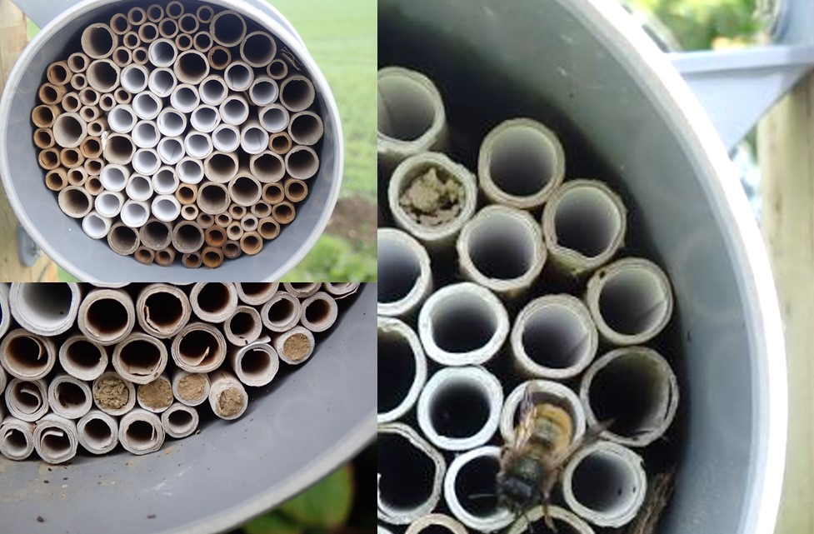

Supplementary File S2. Summary of study site information including area and dates related to flowering period and trapping period. [Actual site locations are not given due to EU GDPR]. Variety represents the main variety grown; ‘Mixed’ indicates that several apple varieties were grown in approximately equal proportions, or that the OSR was a mix of varieties as the crop was intended for poultry feed or fodder for cattle.

Site code | Crop | Variety/CV | County | Area (ha) | Flowering started | Flowering ended |  | Nests installed | Nests removed
01 | OSR | Elgar | Louth | 11.0 | 10/04/19 | 06/07/19 |  | 03/04/19 | 04/09/19
02 | OSR | Mixed | Meath | 19.0 | 07/03/19 | 25/05/19 |  | 02/04/19 | 11/09/19
03 | OSR | Mixed | Meath | 22.0 | 10/03/19 | 31/05/19 |  | 02/04/19 | 11/09/19
04 | OSR | Harnas | Kildare | 0.5 | 20/03/19 | 30/05/19 |  | 01/04/19 | 22/09/19
05 | OSR | Harnas | Kildare | 5.0 | 12/03/19 | 02/06/19 |  | 02/04/19 | 11/09/19
06 | OSR | Harnas | Laois | 10.0 | 07/03/19 | 30/05/19 |  | 01/04/19 | 22/09/19
07 | OSR | Elgar | Louth | 11.0 | 14/03/19 | 30/05/19 |  | 30/03/19 | 04/09/19
08 | OSR | Elgar | Louth | 10.0 | 14/03/19 | 30/05/19 |  | 30/03/19 | 04/09/19
09 | APP | Jonagored | Tipperary | 3.5 | 06/04/19 | 28/05/19 |  | 04/04/19 | 07/09/19
10 | APP | Jonagored | Kilkenny | 2.8 | 06/04/19 | 28/05/19 |  | 04/04/19 | 08/09/19
11 | APP | Cox | Waterford | 4.0 | 06/04/19 | 29/05/19 |  | 04/04/19 | 08/09/19
12 | APP | Cox | Kilkenny | 0.5 | 21/04/19 | 29/05/19 |  | 05/04/19 | 08/09/19
13 | APP | Bramley | Offaly | 0.9 | 16/04/19 | 16/05/19 |  | 19/04/19 | 07/09/19
14 | APP | Discovery | Dublin | 0.4 | 10/04/19 | 31/05/19 |  | 17/04/19 | 04/09/19
15 | APP | Bramley | Dublin | 2.4 | 06/04/19 | 26/05/19 |  | 17/04/19 | 04/09/19
16 | APP | Mixed | Meath | 4.0 | 06/04/19 | 26/05/19 |  | 17/04/19 | 04/09/19

Supplementary File S3. Numbers of adults of five species of stem-nesting Hymenoptera which emerged from nest tubes of different diameters. Values given are mean (minimum-maximum) emergents per tube. P-values for diameter obtained from GLMM with crop and diameter included as fixed factors, site included as random factor, and using a Poisson error structure with log-link function. For summary data across crops see Table 2.

 |  | Tube diameter
Species | 4mm | 5mm | 6mm | 8mm | 10mm |  | P_{Diam}
Hylaeus communis | 6.8 (1-17) | 5 .0 (1-11) | - | - | - |  | 0.629
Osmia bicornis | - | 3.7 (2-6) | 4.1 (1-7) | - | - |  | 0.736
Megachile versicolor | - | - | - | 5.2 (2-9) | 5.1 (1-7) |  | 0.657
Ancistrocerus trifasciatus | 3.4 (1-14) | 3.6 (1-8) | 5.0 (1-11) | - | - |  | 0.253
Ancistrocerus parietinus | - | 3.7 (1-11) | 4.8 (1-7) | 7.7 (2-11) | - |  | 0.214

