DOI: 10.26786/1920-7603(2022)670
Appendices to J Poll Ecol 31(5), Stanley & Cosnett

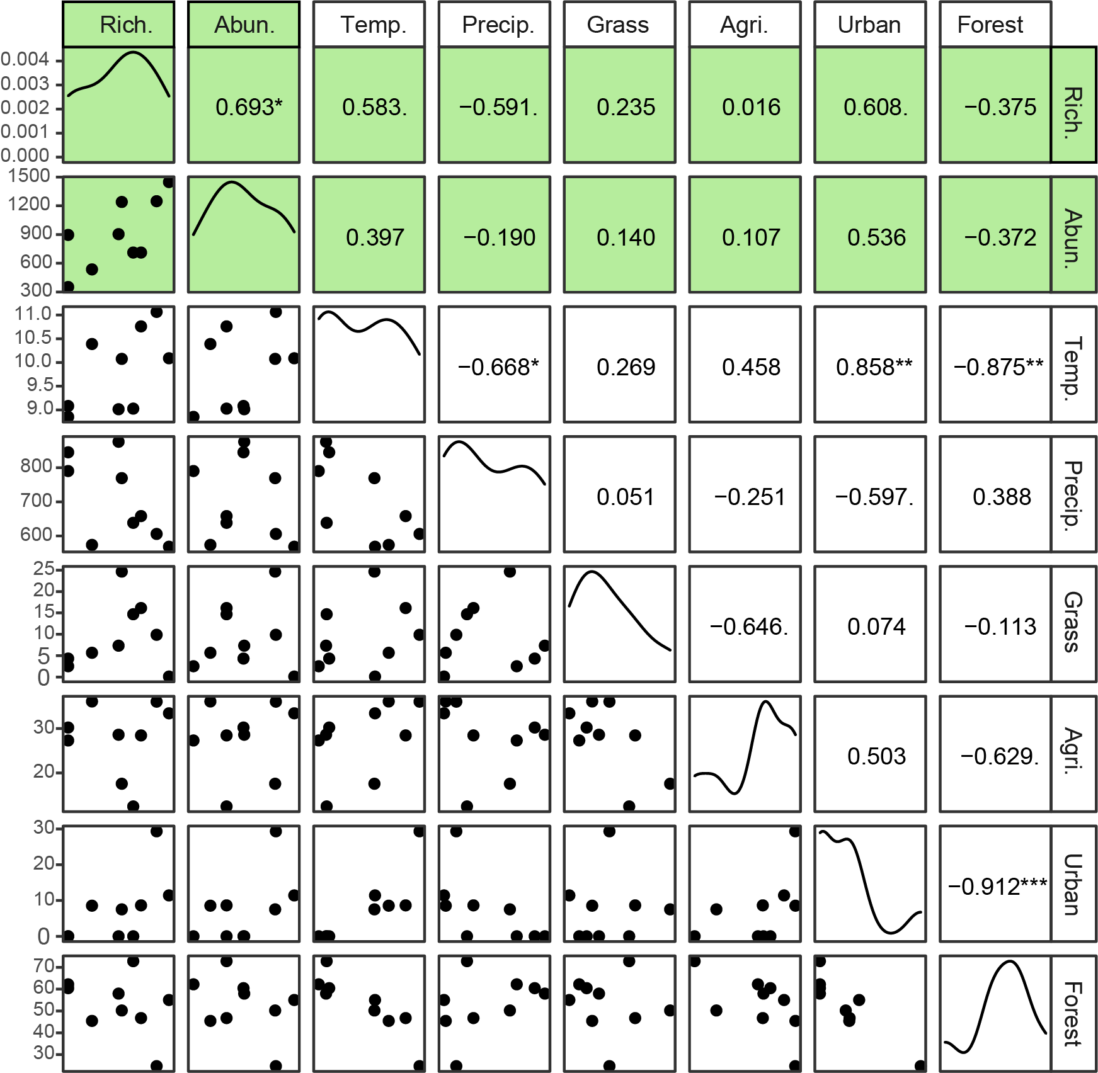
Figure S1. Correlation matrix showing the impact of landscape measures on pollinator species richness (Rich.) and abundance (Abun.) as well as the environmental variability between orchards. All variables were measured in 1km buffer around the orchards. Temp is the mean annual temperature (°C), Precip. Is the mean annual rainfall (mm). The landscape variables measured as a percentage cover within the buffer. Richness and abundance (highlighted in green) were used as the response variables in a linear mixed effects model. No environmental variables showed a significant relationship with either richness or abundance of pollinator species. Value on the upper triangle is the Pearson’s correlation coefficient and the * refer to the p-value significance level; *>0.05, **>-.01, ***>0.0001.

Table S1. Linear mixed effects model to test for the effect of the surrounding landscape and climate conditions on pollinator species richness and abundance per orchard.
 | Species Richness |  |  | Abundance
Predictors | Estimates | CI | p | Estimates | CI | p
(Intercept) | -2338.99 | -6728.07–2050.08 | 0.406 | -14570.7 | -32994.08–3852.7 | 0.573
Annual Temp (°C) | 20.08 | -591.61–631.77 | 0.955 | -648.18 | -3129.22–1832.86 | 0.662
Annual Precip (mm) | 0.17 | -1.43–1.77 | 0.856 | 1.45 | -5.11–8.00 | 0.731
Grassland (%) | 18.11 | -66.01–102.24 | 0.714 | 211.32 | -124.81–547.45 | 0.38
Agriculture (%) | 21.15 | -72.71–115.01 | 0.702 | 253.32 | -120.34–626.98 | 0.383
Urban (%) | 25.6 | -21.20–72.40 | 0.396 | 210.76 | 24.78–396.73 | 0.255
Forest (%) | 23.74 | -22.30–69.79 | 0.419 | 193.54 | 9.52–377.57 | 0.217
Random Effects (District)
σ2 | 5716.51 | 89876.83
τ00 | 0 | 11050.43
ICC |  | 0.11
N | 3 | 3
Observations | 9 | 9
Marginal R2 / Conditional R2 | 0.458 / NA | 0.513 / 0.566

Table S2. Linear mixed effects model to test for the effect pollinator abundance on mean apple weight (g).
 | Mean Weight |  |  | Mean Weight  (excluding total abundance)
Predictors | Estimates | CI | p | Estimates | CI | p
(Intercept) | 58.73 | 50.93–66.54 | <0.001 | 62.8 | 57.78–67.81 | <0.001
Total abundance | 0.05 | 0.04–0.05 | <0.001
Hoverfly abundance |  |  |  | 0.07 | 0.06–0.08 | <0.001
Honeybee abundance |  |  |  | 0.05 | 0.05–0.06 | <0.001
Random Effects
σ2 | 6.53 | 8.12
τ00 | 28.13 | 0
ICC | 0.81
N | 3 | 3
Observations | 9 | 9
Marginal R2 / Conditional R2 | 0.888 / 0.979 | 0.968 / NA

