Appendices

Appendix I – Pollen transfer
Pollinators vary in how they collect nectar in staminate and pistillate flowers because of where the nectaries are in the flowers (1). For example, in staminate flowers, bees are forced into a vertical position to gather nectar, meaning that pollen adheres to the bees’ backs (Nepi, Massimo and Pacini 1993). Once out of the staminate flower, bees tend to sit on a flower or leaf and clean excess pollen grains from themselves using their back legs (Nepi, Massimo and Pacini 1993; Knapp et al. 2018). This usually happens in the first hour of anthesis when pollen grains are plentiful. Nonetheless, many pollen grains will remain on the bees so that once inside a pistillate flower, the bees will inadvertently unload their pollen grains on to the stigma as they make their way to the base of the corolla (Nepi, Massimo and Pacini 1993; Knapp et al. 2018). Here, two to three bees may collect nectar at the same time and continue to shed more pollen grains as they move symmetrically around the whole circumference of the corolla (Figure 1) (Nepi, Massimo and Pacini 1993).
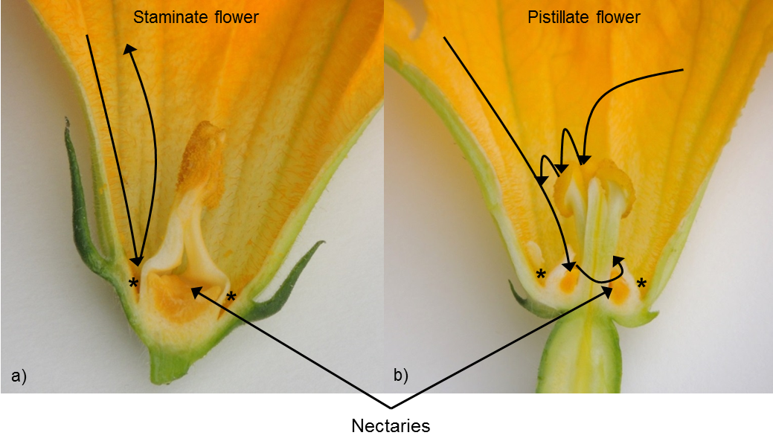
Figure 1Morphology of staminate (a) and pistillate (b) flowers. The nectaries are shown and arrows show the path of bees collecting nectar. Asterisks (*) show where pollen accumulates. Diagram modified from (Nepi, Massimo and Pacini, 1993).

