Appendix 1 A.
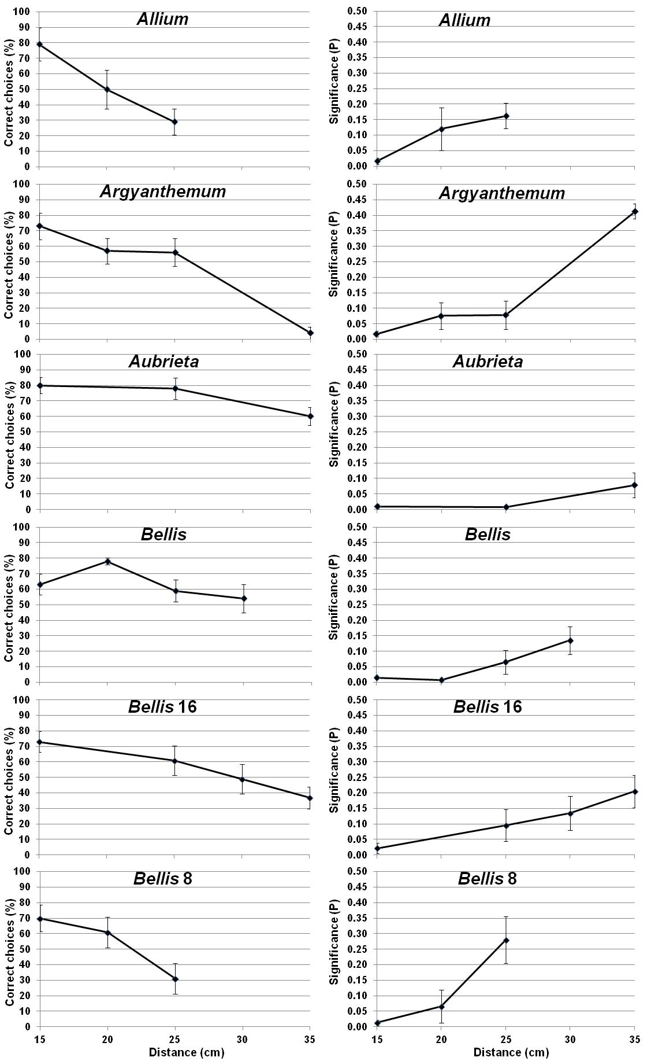

Appendix 1 B.

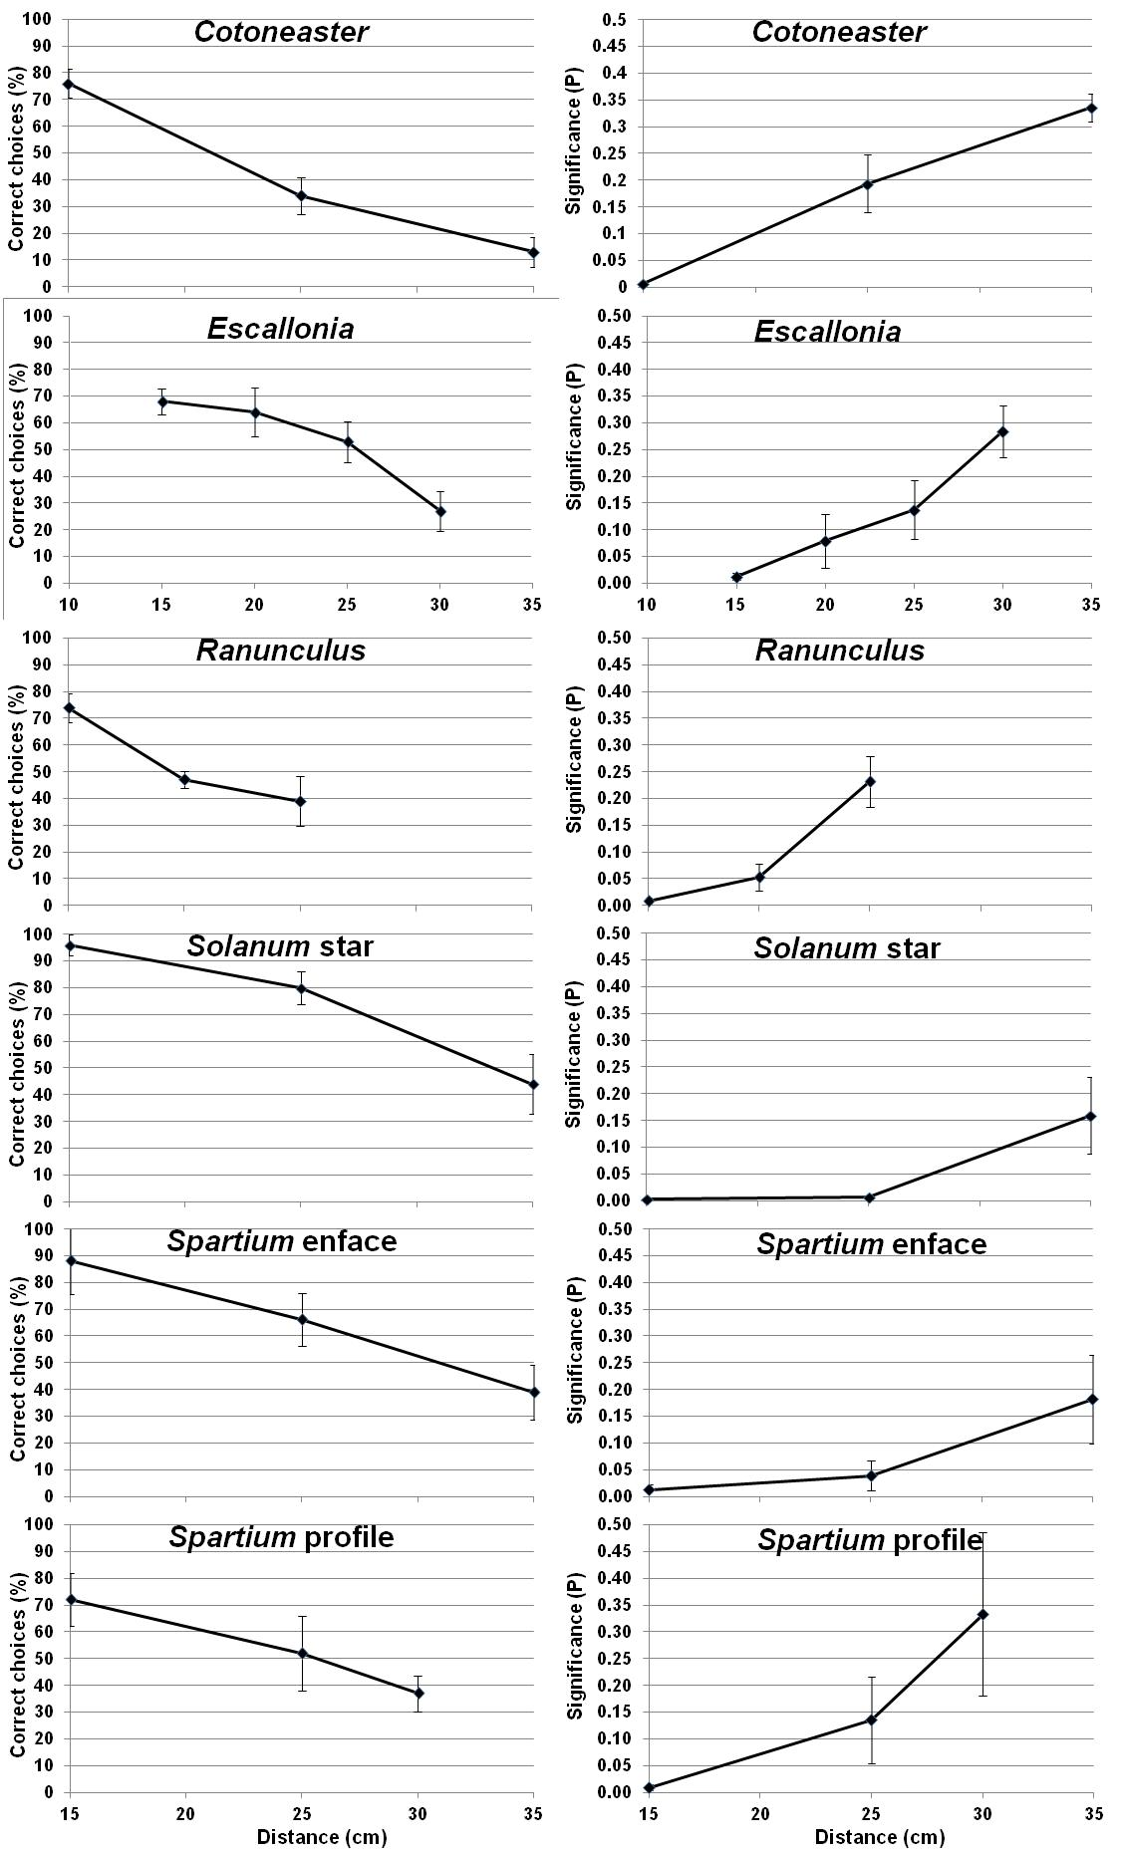

Appendix I.
The average percentage of correct choices of the random rewarding arm (one of six in the radial maze in which the 12 tested flower types were presented) as a function of the distance by Bombus terrestris workers; the correspondent binomial probability (P value) that the number of correct choices were higher than 20% of the total number of trials (range 5-9, average=7); and the number of bees tested for each flower type in each distance for all studied flower types: Allium=Allium cristophii (n=5 bees); Argyanthemum=manipulated Argyanthemum frutescens with 10 petals (n=7); Aubrieta=Aubrieta deltoidea; Bellis= Bellis perennis with reduced diameter (n=7 bees); Bellis16= Bellis perennis with reduced 16 petals (n=7 bees); Bellis8= Bellis perennis with reduced 8 petals (n=5 bees); Cotoneaster= Cotoneaster microphyllus (n=9 bees); Escallonia= Escallonia macrantha (n=6 bees); Ranunculus=Ranunculus bulbosus (n=5 bees); Solanum star=Solanum crispum with reduced area (n=5 bees); Spartium enface=Spartium junceum presented en face (n=5); Spartium profile=Spartium junceum presented in profile (n=5 bees). Manipulated flowers have reduced number of petals as indicated by the number following their name. The visual parameters of the flower types are presented in Table 1.

Appendix II.
Maximal detection distance (MDD) of all tested individual bees (each line presents a single bee) to all tested flowers; flower (coloured) area, average diameter and the contour line (Perimeter) of all tested flowers and the value of the green-receptor contrast between petal colour and the green background of the radial maze against which the flowers were presented to the bees. See also Table 2.

Flower | MDD mm | Area cm² | Diameter mm | Perimeter mm | Green Contr.
Allium cristophii | 27.5 | 111 | 17.13 | 127.89 | 0.3790
Allium cristophii | 17.5 | 111 | 17.13 | 127.89 | 0.3790
Allium cristophii | 22.5 | 111 | 17.13 | 127.89 | 0.3790
Allium cristophii | 22.5 | 111 | 17.13 | 127.89 | 0.3790
Allium cristophii | 22.5 | 111 | 17.13 | 127.89 | 0.3790
Allium cristophii | 22.5 | 111 | 17.13 | 127.89 | 0.3790
Aubrieta deltoidea | 45.0 | 314 | 20.13 | 74.42 | 0.2208
Aubrieta deltoidea | 45.0 | 314 | 20.13 | 74.42 | 0.2208
Aubrieta deltoidea | 30.0 | 314 | 20.13 | 74.42 | 0.2208
Aubrieta deltoidea | 45.0 | 314 | 20.13 | 74.42 | 0.2208
Aubrieta deltoidea | 30.0 | 314 | 20.13 | 74.42 | 0.2208
Aubrieta deltoidea | 30.0 | 314 | 20.13 | 74.42 | 0.2208
Aubrieta deltoidea | 45.0 | 314 | 20.13 | 74.42 | 0.2208
Aubrieta deltoidea | 40.0 | 314 | 20.13 | 74.42 | 0.2208
Argyanthemum frutescens | 30.0 | 606 | 30.26 | 233.53 | 0.4509
Argyanthemum frutescens | 17.5 | 606 | 30.26 | 233.53 | 0.4509
Argyanthemum frutescens | 17.5 | 606 | 30.26 | 233.53 | 0.4509
Argyanthemum frutescens | 30.0 | 606 | 30.26 | 233.53 | 0.4509
Argyanthemum frutescens | 30.0 | 606 | 30.26 | 233.53 | 0.4509
Argyanthemum frutescens | 30.0 | 606 | 30.26 | 233.53 | 0.4509
Bellis perennis | 27.5 | 112 | 11.95 | 47.40 | 0.4995
Bellis perennis | 35.0 | 112 | 11.95 | 47.40 | 0.4995
Bellis perennis | 27.5 | 112 | 11.95 | 47.40 | 0.4995
Bellis perennis | 22.5 | 112 | 11.95 | 47.40 | 0.4995
Bellis perennis | 27.5 | 112 | 11.95 | 47.40 | 0.4995
Bellis perennis | 22.5 | 112 | 11.95 | 47.40 | 0.4995
Bellis perennis | 35.0 | 112 | 11.95 | 47.40 | 0.4995
Bellis perennis 8 | 25.0 | 134 | 16.22 | 142.28 | 0.4995
Bellis perennis 8 | 17.5 | 134 | 16.22 | 142.28 | 0.4995
Bellis perennis 8 | 22.5 | 134 | 16.22 | 142.28 | 0.4995
Bellis perennis 8 | 22.5 | 134 | 16.22 | 142.28 | 0.4995
Bellis perennis 8 | 22.5 | 134 | 16.22 | 142.28 | 0.4995
Bellis perennis 16 | 45.0 | 242 | 21.72 | 259.43 | 0.4995
Bellis perennis 16 | 40.0 | 242 | 21.72 | 259.43 | 0.4995
Bellis perennis 16 | 27.5 | 242 | 21.72 | 259.43 | 0.4995
Bellis perennis 16 | 32.5 | 242 | 21.72 | 259.43 | 0.4995
Bellis perennis 16 | 20.0 | 242 | 21.72 | 259.43 | 0.4995
Bellis perennis 16 | 22.5 | 242 | 21.72 | 259.43 | 0.4995
Bellis perennis 16 | 27.5 | 242 | 21.72 | 259.43 | 0.4995
Cotoneaster microphyllus | 30.0 | 105 | 12.27 | 61.47 | 0.4628
Cotoneaster microphyllus | 20.0 | 105 | 12.27 | 61.47 | 0.4628
Cotoneaster microphyllus | 30.0 | 105 | 12.27 | 61.47 | 0.4628
Cotoneaster microphyllus | 20.0 | 105 | 12.27 | 61.47 | 0.4628
Cotoneaster microphyllus | 20.0 | 105 | 12.27 | 61.47 | 0.4628
Cotoneaster microphyllus | 30.0 | 105 | 12.27 | 61.47 | 0.4628
Cotoneaster microphyllus | 20.0 | 105 | 12.27 | 61.47 | 0.4628
Cotoneaster microphyllus | 20.0 | 105 | 12.27 | 61.47 | 0.4628
Cotoneaster microphyllus | 20.0 | 105 | 12.27 | 61.47 | 0.4628
Escallonia macrantha | 27.5 | 151 | 15.18 | 63.34 | 0.2546
Escallonia macrantha | 17.5 | 151 | 15.18 | 63.34 | 0.2546
Escallonia macrantha | 27.5 | 151 | 15.18 | 63.34 | 0.2546
Escallonia macrantha | 22.5 | 151 | 15.18 | 63.34 | 0.2546
Escallonia macrantha | 22.5 | 151 | 15.18 | 63.34 | 0.2546
Escallonia macrantha | 27.5 | 151 | 15.18 | 63.34 | 0.2546
Ranunculus bulbosus | 22.5 | 174 | 15.01 | 54.55 | 0.4679
Ranunculus bulbosus | 22.5 | 174 | 15.01 | 54.55 | 0.4679
Ranunculus bulbosus | 22.5 | 174 | 15.01 | 54.55 | 0.4679
Ranunculus bulbosus | 30.0 | 174 | 15.01 | 54.55 | 0.4679
Ranunculus bulbosus | 22.5 | 174 | 15.01 | 54.55 | 0.4679
Ranunculus bulbosus | 22.5 | 174 | 15.01 | 54.55 | 0.4679
Solanum crispum star | 27.5 | 190 | 20.74 | 126.33 | 0.4269
Solanum crispum star | 17.5 | 190 | 20.74 | 126.33 | 0.4269
Solanum crispum star | 22.5 | 190 | 20.74 | 126.33 | 0.4269
Solanum crispum star | 22.5 | 190 | 20.74 | 126.33 | 0.4269
Solanum crispum star | 22.5 | 190 | 20.74 | 126.33 | 0.4269
Spartium junceum (en face) | 20.0 | 510 | 26.44 | 116.96 | 0.3789
Spartium junceum (en face) | 40.0 | 510 | 26.44 | 116.96 | 0.3789
Spartium junceum (en face) | 30.0 | 510 | 26.44 | 116.96 | 0.3789
Spartium junceum (en face) | 40.0 | 510 | 26.44 | 116.96 | 0.3789
Spartium junceum (en face) | 30.0 | 510 | 26.44 | 116.96 | 0.3789
Spartium junceum (profile) | 20.0 | 288 | 25.14 | 112.51 | 0.3789
Spartium junceum (profile) | 27.5 | 288 | 25.14 | 112.51 | 0.3789
Spartium junceum (profile) | 20.0 | 288 | 25.14 | 112.51 | 0.3789
Spartium junceum (profile) | 27.5 | 288 | 25.14 | 112.51 | 0.3789
Spartium junceum (profile) | 35.0 | 288 | 25.14 | 112.51 | 0.3789

