Appendix I. List of materials used to build artificial flowers.

Part/material | Function | Vendor | Part number | Description | Cost per package | Amount per package
SOLENOID AND PLATFORM:
Heavy wire | Hold spring in position above solenoid | Lowes | 52689 | The Hillman Group 16-Gauge Dark Annealed Picture Hanging Wire | $9.41 | 2 lbs.
Spring | Hold platform and arms up when solenoid is not turned on | Ace Hardware | N/A | #78 spring | $0.82 | 1
Solenoid | Pull the platform and arms down to dip into the reservoirs | Electronic Surplus | SOL-20 | Solenoid, AC. Coil: 26VAC 0.75A 5.5 Ohms Part # SOL-20, SKU 7687 | $2.95 | 1
Electrical wire | Connect solenoid to power supply | All Electronics Corporation | 20BK-100 | 20-gauge stranded hook-up wire | $9.46 | 100 foot roll
Power supply | Convert power from wall outlet to 12V | Circuit Specialists | PS1-240W-12 | 12V 18A switching power supply | $34.95 | 1
Lubricant | Lubricate solenoid | Ace Hardware | N/A | Inox lubricant | $9.49 | 100g
Foam tape | Cushion solenoid when plunger pulls down (optional) | Lowes | 66673 | M-D Building Products 0.375-in x 17-ft Gray Closed-Cell Foam Window Weatherstrip | $2.42 | 17-foot roll
Light-weight, green fabric | Cover solenoid and spring to prevent bees from damaging the solenoid or being trapped in the working parts | Jo-Ann Fabrics | N/A | N/A | $3.99 | Yard
Cord | Form drawstrings holding ends of fabric cover shut | Jo-Ann Fabrics | N/A | N/A | $0.99 | Yard
Sew-on velcro | Help hold fabric cover closed around the wires to the solenoid (optional) | Jo-Ann Fabrics | 12149241 | Sew-on Velcro | $3.99 | Yard
PLATFORM AND ITS ATTACHMENT TO SOLENOID
Washer | Form the platform, attached to the plunger of the solenoid, that the arms attach to; an additional washer can be bolted in place over the arms to hold them more securely | Lowes | 2769 | The Hillman Group 30-Count 1/4-in x 1-1/4-in Zinc-Plated Standard (SAE) Fender Washers | $6.58 | bag of 30 washers
Toothpicks | Glued to platform to keep magnets from sliding on platform, or from touching, if multiple arms are attached to platform (optional) | Various | N/A | Flat toothpicks | N/A | N/A
Large bolts | Hold washer tight over the arms, securing them to the platform (optional) | Lowes | 72353 | The Hillman Group 50-Count #1/4-20 x 1/2-in Round-Head Standard (SAE) Machine Screws | $6.58 | 1 package of 50
Wing nuts | Hold washer tight over the arms, securing them to the platform (optional) | Lowes | 67825 | The Hillman Group 50-Count 1/4-in-20 Zinc Plated Standard (SAE) Regular Wing Nuts | $6.88 | 1 package of 50
Corner | Attach to solenoid plunger, allowing it to be attached to platform | Lowes | 364270 | The Hillman Group 1/2-in x 1/2-in x 1/2-in Metal 90-Gauge Corner | $3.68 | bag of 4
Brackets | Attach to underside of platform, allowing it to be attached to the solenoid plunger | Lowes | 364311 | The Hillman Group 1/2" x 1-1/2" x 1-1/2" Metal 90D Plate | $1.58 | bag of 2
3-inch mending plate | Half of a mending plate is glued to the corner attached to the solenoid and half is glued to the bracket attached to the platform, to allow them to be bolted securely to a 4.5-inch mending plate holding the two together | Lowes | 364323 | The Hillman Group 1/2" x 3" x .035" Metal Mending Plate | $2.88 | bag of 6
4.5-inch mending plate | Holds the platform above the plunger | Lowes | 364404 | The Hillman Group 1/2" x 4.5" x .035" Metal Mending Plate | $3.48 | bag of 6
Small nuts and bolts | Attaching platform and solenoid to the 4.5-inch mending plate | Lowes | 122887 | The Hillman Group 100-Count #6-32 x 3/8-in Round-Head Standard (SAE) Machine Screws | $4.58 | container of 100 screws
Epoxy | Attach metal components together | Ace Hardware | 12286 | Loctite Epoxy, Quick SetTM, Multi-purpose | $5.99 | 0.85 oz
Super glue | Attach toothpicks to platform (optional) | Ace Hardware | 1024413 | Loctite Super Glue Gel | $3.59 | 4g
DIPPERS (ARMS AND BRASS RODS):
4.5-inch mending plate | Arm that connects brass rod to platform is made from half of a mending plate | See above
Brass rods | Dip into the reservoir to lift up a small droplet of solution | Ace Hardware | 8162 | Brass Rod, 1/16 (1.57mm), K&S Precision Metals | $2.29 | 3 pieces
Primer | Adjust appearance of metal arm and protect metal from rust | Ace Hardware | N/A | Ace Rust Stop Oil Based Primer, Red | N/A | 32 fluid ounces
Paint | Adjust appearance of metal arm and protect metal from rust | Ace Hardware | N/A | Ace Rust Stop Indoor/Outdoor Oil Based Enamel, Hunter Green | $9.99 | 32 fluid ounces
Small, stainless-steel hex nuts | Hold brass rods onto arms | Lowes | 409466 | The Hillman Group 20-Count #6- 32 Stainless Steel Standard (SAE) Hex Nut | $1.98 | Bag of 20
Narrow vinyl tubing | Hold hex nuts in place on brass rods | Fisher Scientific | 14-176-191 | Thermo Scientific Nalgene 180 Clear Plastic Tubing; PVC; I.D. x O.D. x Wall: 1/16 x 1/8 x 1/32 in. | $29.10 | 50 ft
Magnets | Hold arms in position on the platform | All Electronics Corporation | MAG-122 | 0.5" diameter x 0.15" ceramic magnet | $0.08 | 1
Super glue | Attach magnets to arms | See above
FLOWER COVERS:
Copper wire | Hold flower petals in place and serve as handles for reservoir covers | Lowes | 62938 | The Hillman Group 18-Gauge Copper Picture Hanging Wire | $4.98 | 25 ft.
Vials | The bottom of the vial is sawed off to make a plastic cover for the reservoir | Fisher Scientific | 03-338-3C | Fisherbrand Polystyrene Containers, 7 dram (25.9 mL), 26 x 51 mm) | $62.00 | Case of 144 vials
Hot glue | Attach copper wire to reservoir covers | Various | N/A | All purpose glue sticks | N/A | N/A
STEMS, CALYXES AND RESERVOIRS:
Vials | Reservoirs and platforms on which the reservoirs rest | Fisher Scientific | 03-388A | Thermo Scientific 5 mL Sample Vials with Snap Closure, LDPE | $15.20 | Bag of 12 vials
Hot glue | Attach wood pieces together | See above
Dowels | Form "stems" of flowers | Lowes | 27594 | Madison Mill 3/8"Dia. x 36"L Poplar Square Dowel | $1.04 | 1
Wood planks | Form the base of the flowers | Home Depot | PNE0267 | Woodgrain Millwork WM 267 1-5/16 in. x 1/4 in. Pine Lattice Moulding | $0.79 | Foot of moulding
Washers | To adjust height of reservoirs | Various | N/A | 3/4 inch diameter flat washers | N/A | N/A

Appendix II. Dimensions of the “calyx” of the artificial flowers.

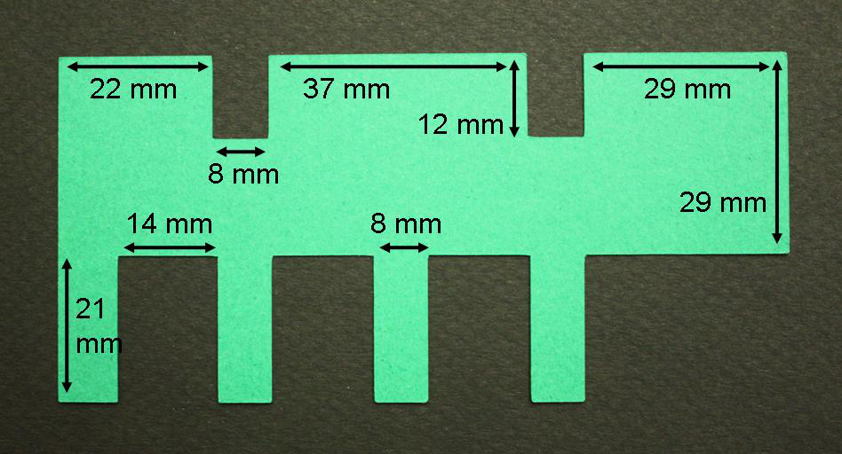

Appendix III. Dimensions of a sample “corolla” for the artificial flowers.

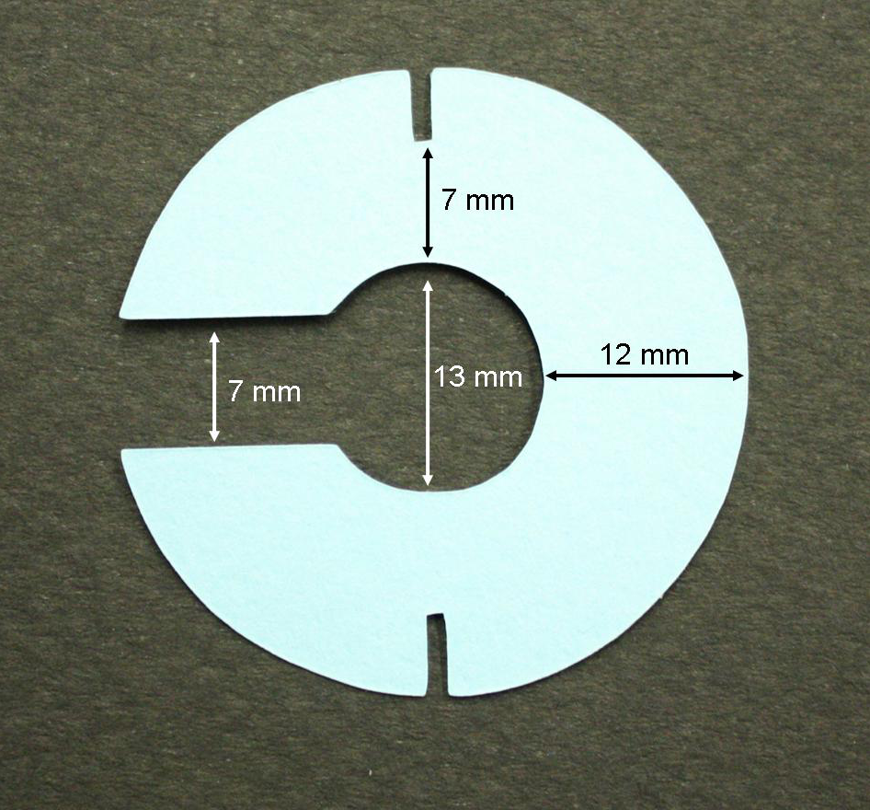

Appendix IV. Instructions for sewing a cloth sleeve to cover the solenoid and spring of the artificial flowers.

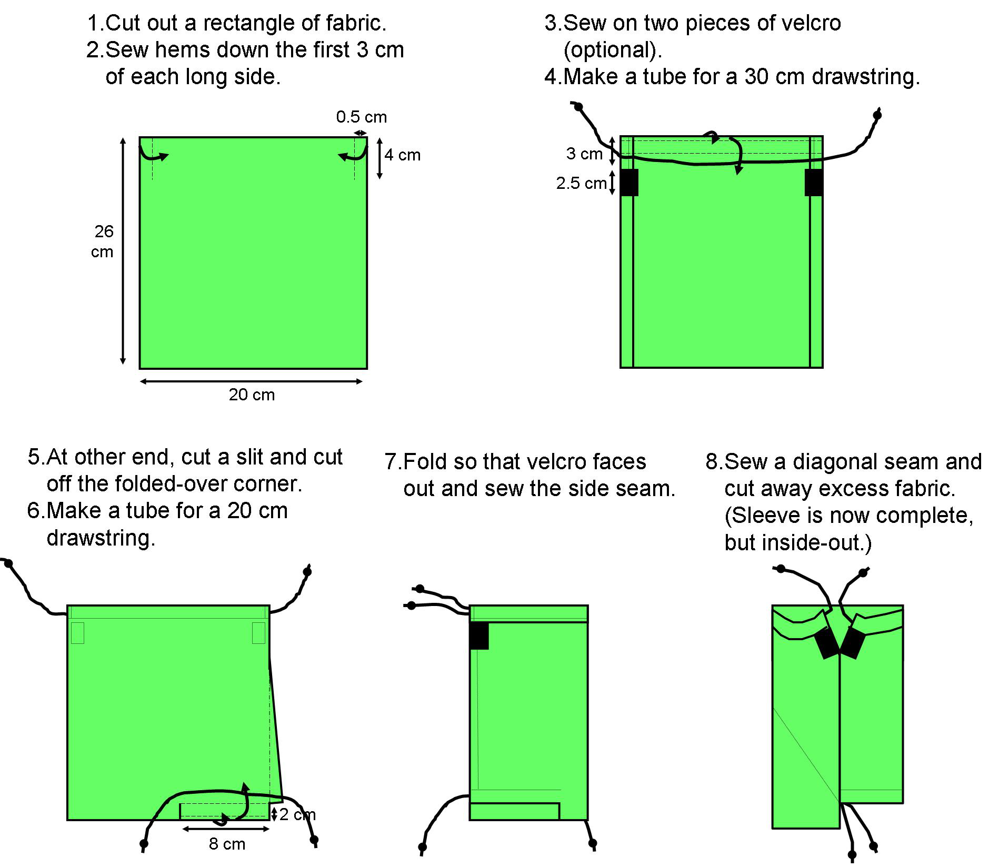

Appendix V. “Training flower” used to train bees to visit flobots, shown partly disassembled (a) to show the reservoir and fully assembled (b). The rubber band below the flower, which can be used to hold the flower cap securely in place, and the microcentrifuge tube taped to the flower, which can hold a scented cotton swab, are optional additions not described in the text.

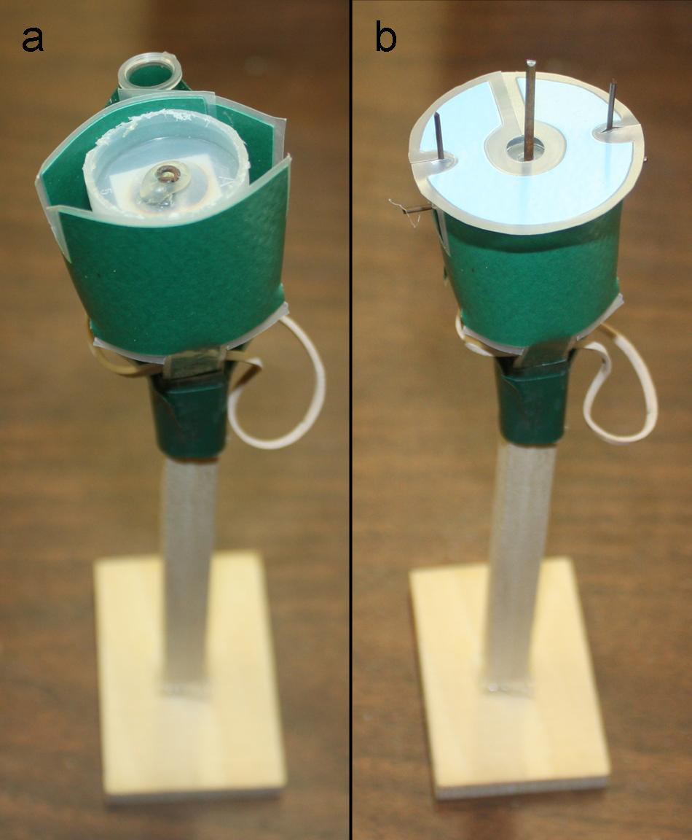

Cost is in U. S. dollars.

