How to install and use the IDmethod add in

Open Excel 2010
Select File->Options->Add-Ins and press go (see figure) to see the add ins
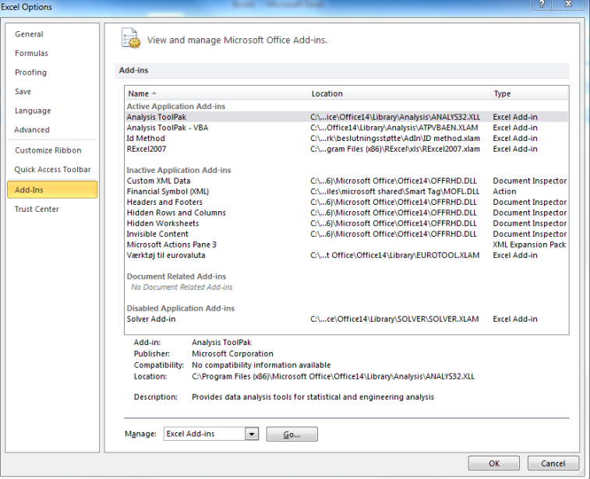

The IDmethod is not known by Excel, thus you shall press Browse and select the place I your computer, where you have placed the add in, see figure below:

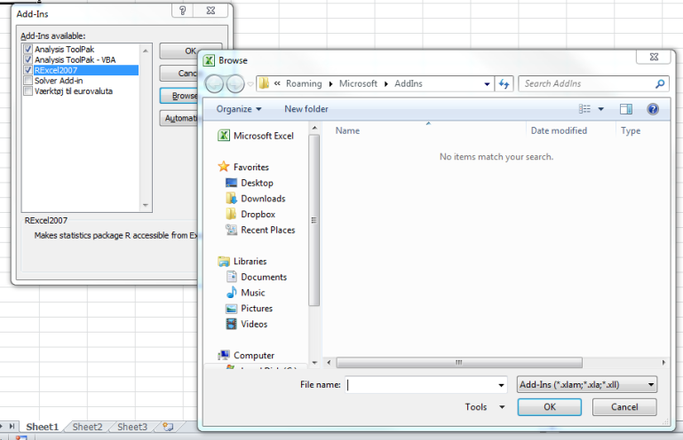

Then press ok and the IDmetod will be included in the list of add ins as seen in the next figure:

You can make the add in as active/inactive by the tick, it has to be active for use and press ok.
Now Excel is connected to the add in, but you have to make it assessable for you.
Select File->Options->Customize Ribbon and select Macros as seen in the figure:
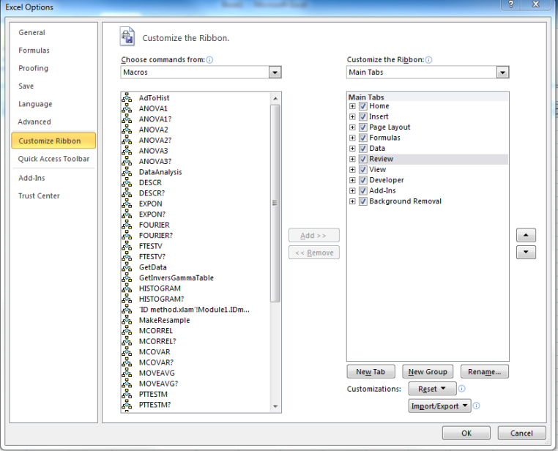

Select Formulas and make a new group as shown:

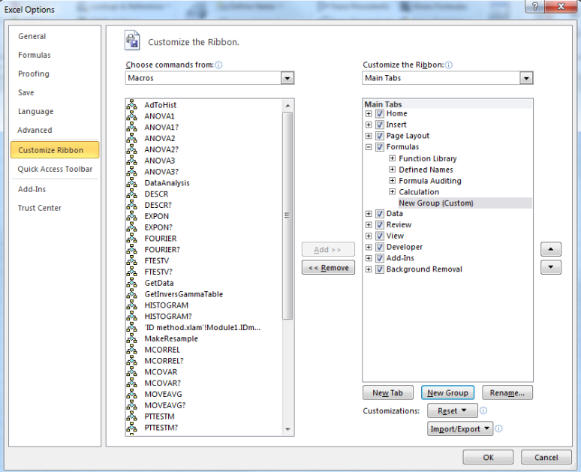

You can rename the new group as follows:
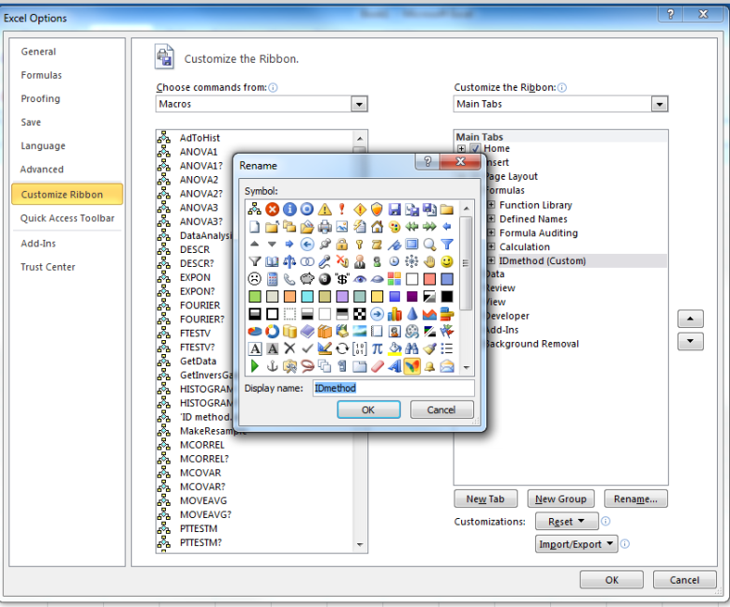

Select the add in on the left panel and the new group to the right and press Add as follows:

After you have added the IDmethod add in to your new group then press Ok and you are ready to run the program. The program is now assessable in the ribbon “Formulas” as a bottom as show in the following:
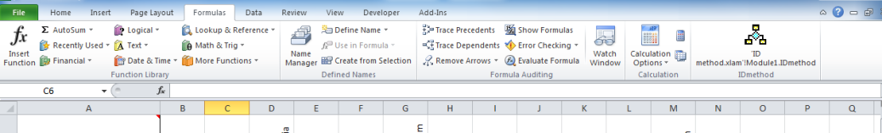

For illustration you can try to open a new sheet and type the following data somewhere in a sheet:

The rows could be pollinators and the columns could be flowers. “0” and empty cell are considered similar. “-1” is considered as null (not possible to make any visit for this combination).
You can start the add in by selecting Formulas in the ribbon above and press the bottom for the IDmethod you have just installed. Then a form is coming like:
The form ask you to click with the mouse in the sheet where you have the data and in the corner of the table. Thus in the example the mouse has to click in cell C7:
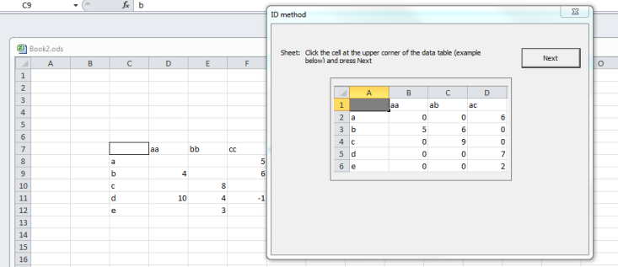
Then press Next in the form and a new form will appear:
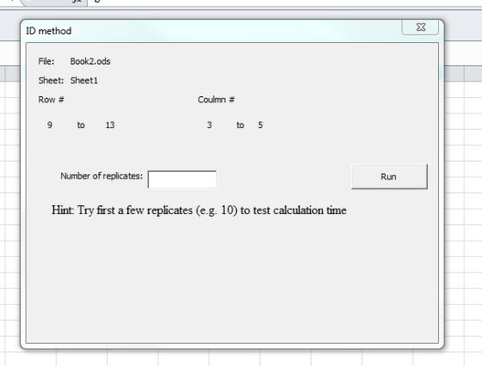
This form tells you that the data table is found between row 9 to 13 and column 3 to 5. The number of replicates can be written to the form. For larger data set the calculation time needs to be tested by a smaller number of replicates (e.g. 10).
Important in the special case where you already have a sheet called “Histogram” in the workbook containg results you wouldl like to keep then rename this sheet before you are running the add in.
Try to type “10000” as the number of replicates and press Run. The calculation will take some seconds and then the following message comes up:

The message tells that a text file has been made in where all single replicates are listed, thus there are 10000 simulated data tables in this file that can be imported in any software for more close analysis.
The add in has made a new sheet called Histogram. In case such a sheet exist in the work book then all content of the old sheet is replaced by the new results. The new results look like:
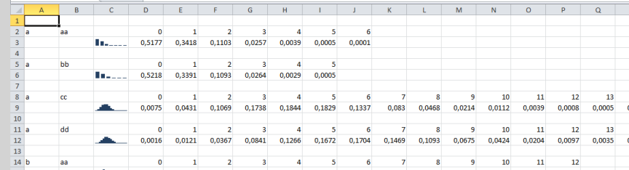
First column is the name of the row and the second column is the name of the columns in the original data table. The numbers show the fractions of resampling’s, where the specific number of “observations” is made. Thus, for the combination of “a” and “aa” a fraction of 0.5177 samplings has contained “0” observations etc. The column C contains sparklines (small in-cell histograms) for fast over look.
Any kind of comments send to me are welcome (Peter Borgen Sorensen, email: pbs@dmu.dk) and on this mail you can be included in a mail list for updates and discussions. The source code is open for inspection and future work in the VBA editor. The add in will be developed during time and if you would like to contribute to that send med mail
I hope you will enjoy the add in.

