APPENDICES
Appendix 1.- Brachigastra mellifica lateral (left) and ventral view (right). Two white avocado pollen grains can be seen on the base of the first left leg (white arrow).

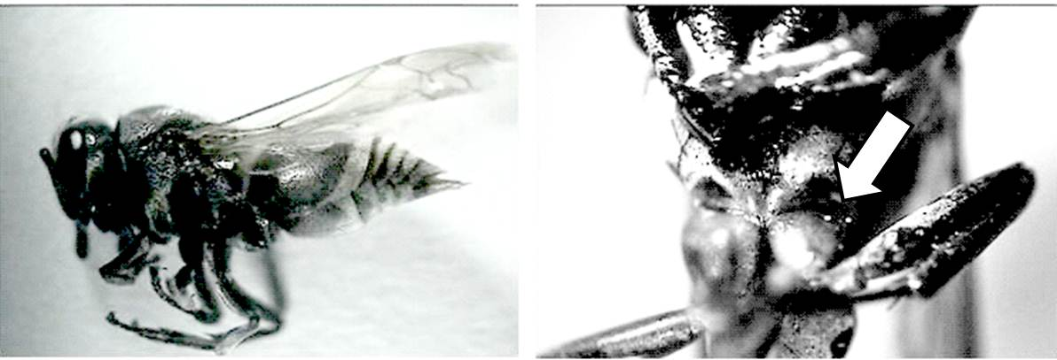

Appendix 2. Chrysomya megacephala (Diptera) (A); and honey bee (Apis mellifera) (B) visiting virgin avocado flowers on a stick.

A.

B.

